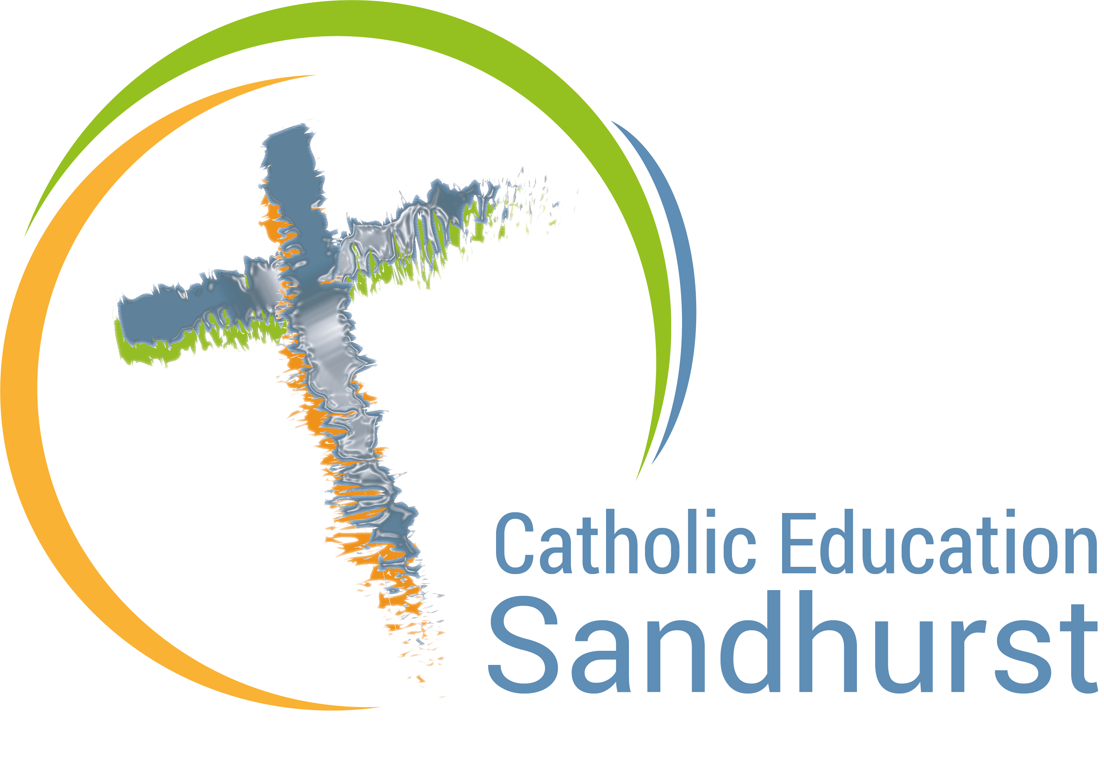

Recontextualising Sacred Space
in Catholic Education

A sacred space is an internal or external area of a Catholic School that symbolizes and celebrates the Catholic faith in a contemporary manner. The aim of these spaces is to draw our minds towards prayer and our hearts towards God in a way that deepens our faith. They reflect our desire to experience the Christian story in the context of current culture. Through their simplicity, beauty and relevance sacred spaces become an essential tool that enables our multi faith and multi belief communities to grow and prosper with Christ at the centre. Schools are encouraged to develop a dialogical pedagogy around sacred space that will ensure our staff and students develop an explicit, recontextualised understanding of Catholic imagery.

Sacred Space in Catholic schools needs to:

- reflect the liturgical year through the use of correct liturgical cloths (purple, green, red or white) and key liturgical symbols (cross, candle, Advent wreath or ashes)
- in addition to a liturgical cloth, include a candle, an open Bible and cross
- reflect the beauty, simplicity and sacredness of our Christian tradition
- inspire dialogue with surrounding culture and other faiths
- be meaningful, relevant and challenging to all present at prayer
- be unpredictable, surprising and hospitable
- be constantly monitored, changed and kept clean
- be kept free from clutter and unrelated items such as whiteboard pens, tennis balls, water bottles or used worksheets
- take pride of place in our foyers, principals’ offices, staff rooms and key learning spaces
- contain religious imagery that is contemporary and student friendly (age appropriate)
- reflect the school’s charism and founding religious order
- link to Indigenous symbolism (message stick, fire carrier flame and Indigenous cross)

How is your sacred space relevant, meaningful and contemporary in a way that celebrates the
Catholic faith in our modern world?

Sacred Space Learning Walk

The following learning walk can be completed every year by the Catholic Identity leader or other staff members. Simply walk around your school and mark each sacred space against this self auditing tool. For the best outcome, results can form the basis of a dialogue and action plan with staff and students.

Mark each box with a number and any relevant comments:

1- needs significant development 2- needs some development 3- needs little development

Essential Items | Liturgical cloth, candle and bible (age appropriate) | Tub in key areas for additional items | Cross or crucifix for the wall and sacred space | Appropriate symbols for the liturgical season | Student friendly and contemporary | Items symbolizing contemporary culture
School Foyer
Staffroom
Exterior
Principal’s office
Learning Areas
(add additional rows for more learning areas if required)

Future recommendations in order of priority:

- ______________________________________________________________________
- ______________________________________________________________________
- ______________________________________________________________________

Sacred Space Action Plan:

Step 1: ___________________________________________________________________
Step 2: ___________________________________________________________________
Step 3: ___________________________________________________________________


For further assistance contact:

Kylie Smith
Spirituality and Faith Formation
Sandhurst

M: 0408 683 788
ksmith@ceosand.catholic.edu.au

