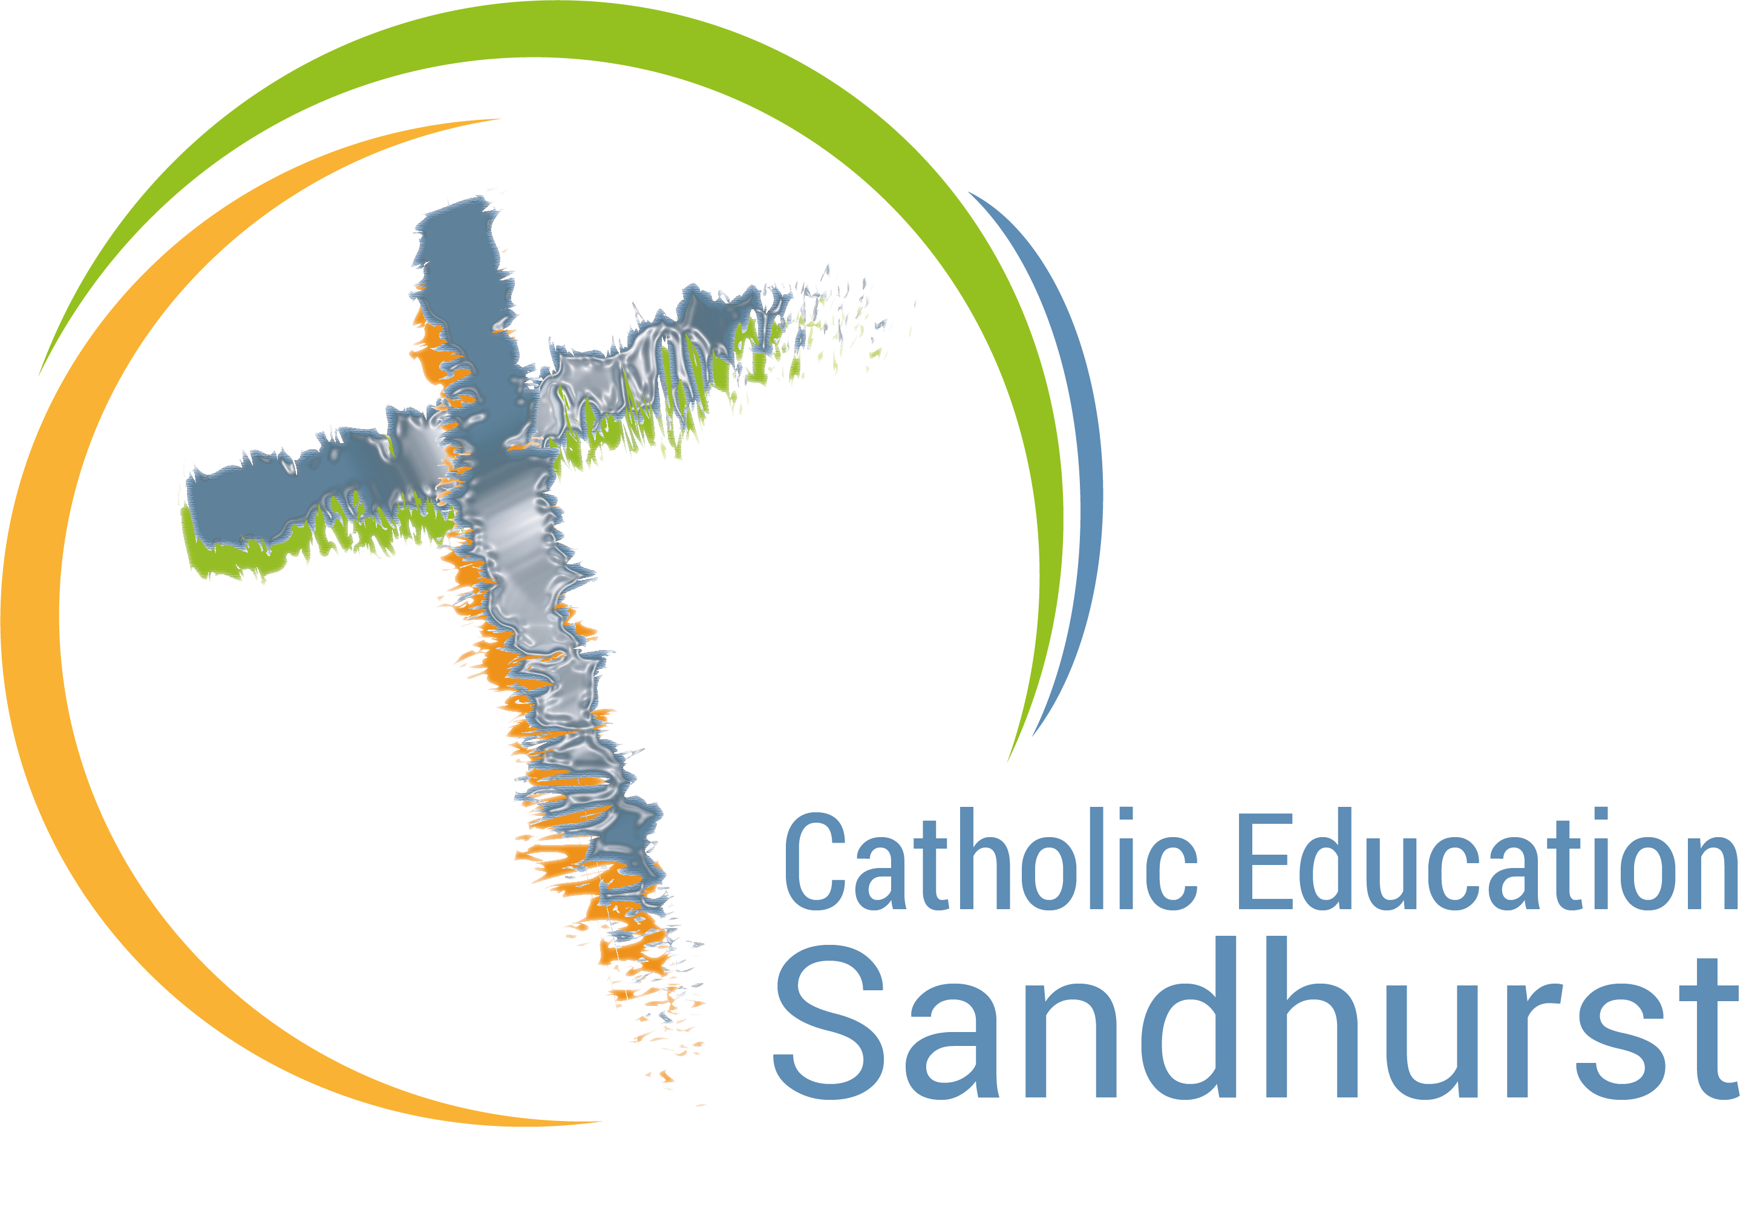

Recontextualising Charism in Catholic Education
Action Research Project 2021

Dear Colleagues,

Catholic Education Sandhurst is very pleased to offer a significant action research project in Recontextualising Charism for 2021. This project is available to secondary and primary schools who are interested in engaging through dialogue, reflection and analysis to improve this essential element of Catholic Identity. As Catholic Identity is central to the mission of Catholic education, this is a significant opportunity for our schools to build understanding, reconnect with and celebrate their school charism.

Research Question:

How can charism become engaging, meaningful and relevant in our current context of secularization, detraditionalisation and pluralization?

Purpose:

- build staff and student understandings of charism and a school’s particular charism
- improve the status of charism in the school through research, professional development, data collection and goal setting
- ensure a school community celebrates, loves and lives their charism into the future

Participants:

- A school charism team of approximately three staff members. Team membership is flexible based on school size.
- The Religious Education Coordinator/Catholic Identity Leader is an essential member of this team.

Procedure and Methodology:

- A school identifies the need to participate in the project based on their strategic plan.
- A charism team is developed to drive the project at each school.
- A project road map and timeline will be developed for each participating school.
- Qualitative and quantitative data will be gathered and interpreted.
- Staff will be immersed in ongoing professional development around charism.
- A charism team will work to develop the framework and curriculum.
- Outcomes and implications of the action research will be developed at the conclusion of the project.

Proposed Time Commitment:

- 3-4 staff meetings (whole staff)
- 3 full days for research and writing (charism team)
- incidental meeting with the CEO project coordinator (charism team)

Kylie Smith

ksmith@ceosand.catholic.edu.au
ph. 0408 683 788

We look forward to your interest in this significant action research project for Catholic Identity in 2021.

