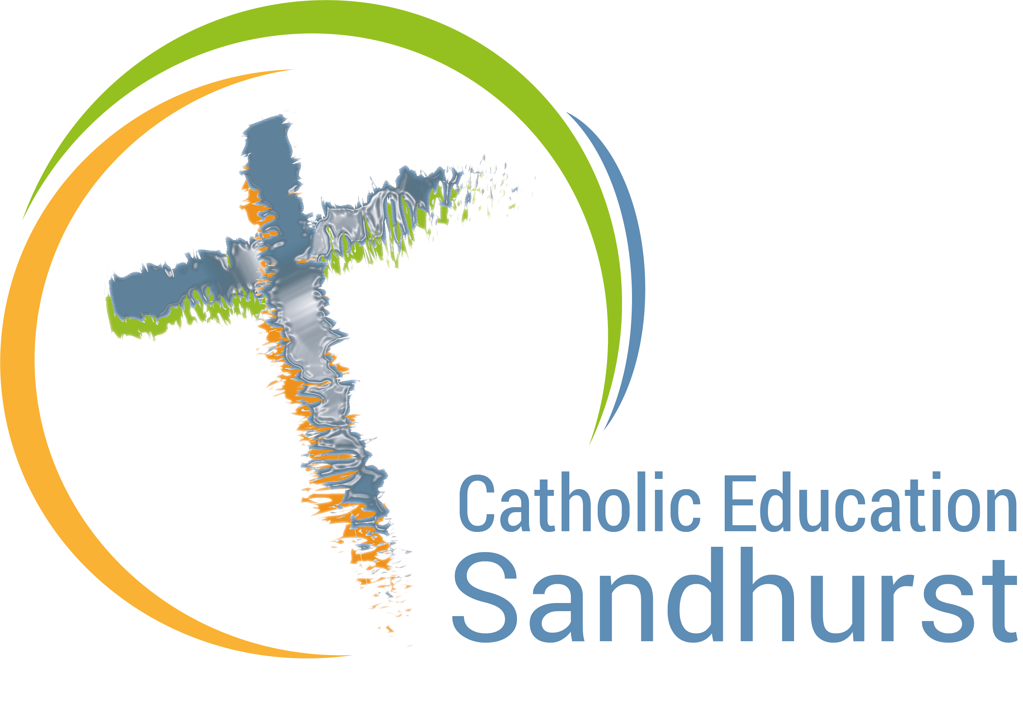
Recontextualising
Ecological Stewardship
Action Research Project
2021

Catholic Education Sandhurst is offering an exciting Action Research Project in Recontextualising Ecological Stewardship in 2021. This project involves engagement through dialogue, reflection, professional development and analysis to bring about improvement in this essential area of Catholic Identity. As Catholic Identity is central to the mission of Catholic education, this is a significant opportunity for your school to build understanding and celebrate this important pillar of our tradition.

Research Question:

How can Ecological Stewardship become engaging, meaningful and relevant in our current context of secularization and pluralization?

Purpose:

- develop staff and student understandings around ecological stewardship in the Catholic tradition
- ensure a strong connection exists between ecological stewardship and sustainability
- bring about improvement through research, professional development, data collection and goal setting

Participants:

- all staff – staff meetings
- Catholic Identity Leader (leader of project and core team)
- 2 staff members (members of the core team)

Procedure and Methodology:

- Identify the need to participate in the project.
- A core team is developed to drive the project at school.
- A project road map and timeline will be developed for the school.
- Qualitative and quantitative data will be gathered and interpreted.
- Staff will be immersed in ongoing professional development.
- Outcomes and implications of the action research will be developed at the conclusion of the project.

Proposed Time Commitment:

- Professional development sessions for all staff
4 staff meetings
- Survey participation by all staff (beginning and end of project)
- Ongoing meetings with the core team (3 meetings a year)
- Incidental meetings with the CEO project mentor – Kylie Smith

ksmith@ceosand.catholic.edu.au
ph. 0408 683 788

I look forward to your involvement in this significant action research project for Catholic Identity in 2021.

Yours Sincerely,



Kylie Smith
Spirituality, Faith Formation and Sustainability
Catholic Education - Sandhurst

