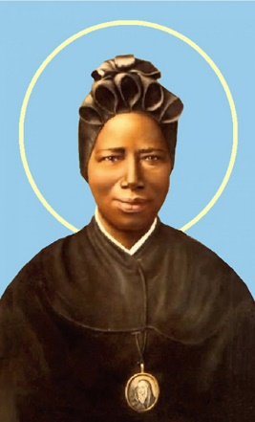
ST JOSEPHINE BAKHITA
Feast Day February 8

The Feast Day of St Josephine Bakhita celebrates the patron saint of victims of modern slavery and human trafficking. It is a day when Catholics are encouraged to remember and pray for all those affected by modern slavery and human trafficking, and those who work to eradicate this crime.
St Josephine Bakhita, also known as “Mother Moretta”, was kidnapped in Africa at the age of nine and sold into slavery before her suffering was alleviated in 1882 when she was taken to the Italian Consul. She later entered a second Italian home, where she received kindness, respect, peace and joy.
A change in her owner’s circumstances meant that she was entrusted to the Canossian Sisters and over the next 50 years she was a source of encouragement through her constant smile, humility and simplicity.
Surrounded by the sisters, she died on 8 February 1947. This date is now a day of prayer, reflection and action to end the injustice of human trafficking.
St Josephine was canonised by Pope St John Paul II on October 1 2000

Prayer
Saint Josephine Bakhita, you remained strong and brave through years of slavery. You used your knowledge and experience in helping to prepare Sisters who were going to work in Africa. Your gentle manner brought peace and strength to all. Help us to have courage when times are hard; help us to be strong and supportive to anyone in need; help us always to remain close, as you were, to Jesus, and show his love to all. Amen.

It is estimated that over 40 million people are trapped in slavery globally – and that one in four of these is a child. These people will probably never receive an education and will almost certainly never sip a latte or enjoy a cuppa in their staffroom.
Many products we buy come from producers who use child labour and forced labour, often involving trafficked children and adults. Even if these workers are not slaves, they live and work in slavery-like conditions, which are often unsanitary and dangerous, for less than the minimum wage.
We know this situation is particularly rife in the production of coffee, tea and cocoa. It is distressing to think that a refreshing beverage, or piece of chocolate, bought locally can be traced back to beans picked by children working in slavery conditions in a far-away country.
While a legal imperative looms (in light of the Federal Government’s new Modern Slavery legislation), there is first and foremost a moral imperative for CES to lead the way in educating members of our community to bring an end to slavery and human trafficking by making simple and practical consumer decisions. The buying decisions we make can change the world. Pope Francis reminds us that ‘every person ought to have the awareness that “purchasing is always a moral – and not simply an economic – act”’ (Message for the World Day of Peace 2015, n. 5). As a community we need to be thinking about where our coffee (and tea) is coming from.
Catholic Education Sandhurst is moving towards being a slavery-free organisation. Following successful Fairtrade Fortnight morning teas across our three offices in August 2019, our next step is to ensure that all tea, coffee and drinking chocolate we buy for and consume in our staffrooms has been produced without the use of any forced or slave labour permanently. From now on our staffrooms will only buy and consume tea, coffee and drinking chocolate that is certified as slave-free by Fairtrade, UTZ or Rainforest Alliance and features one of their labels.
Prayers of Intercession
Leader: As we honour the memory of St Josephine Bakhita, the patron saint of trafficked people, let us pray that God’s freedom and justice will come for all.
Our response is: God of life, hear our prayer.

- We pray for the men and women trapped in bonded labour in fields, market gardens, mines and factories, that they will be respected as human beings rather than reduced to commodities and tools of production. God of life, hear us.
Response: God of life hear our prayer.

- We pray for an end to all discrimination, but especially discrimination against women and girls (who are estimated to make up 80% of trafficked victims), so that all may live with dignity and respect. God of life, hear us.
Response: God of life hear our prayer.

- We pray that wealthy countries like Asutralia may be generous in supporting impoverished nations so that all people have a decent standard of living and escape the desperate circumstances that make them vulnerable to human trafficking. God of life, hear us.
Response: God of life hear our prayer.

- We pray that our demand for cheap goods and services will be reduced so that workers’ conditions and payment will reflect the dignity of their persons and their work. God of life, hear us.
Response: God of life hear our prayer.

We are joining a growing number of dioceses and schools to make this transition including Catholic Education Melbourne and the Catholic Archdioceses of Melbourne and Sydney. We encourage other Sandhurst schools and families to follow our lead.
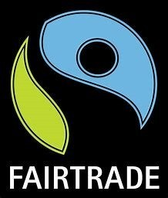
If anyone wants more information on our action, or some tips on going slavery-free, please contact David Walker (0439 201 307 or dwalker@ceosand.catholic.edu.au).
