MODERN SLAVERY AND HUMAN TRAFFICKING

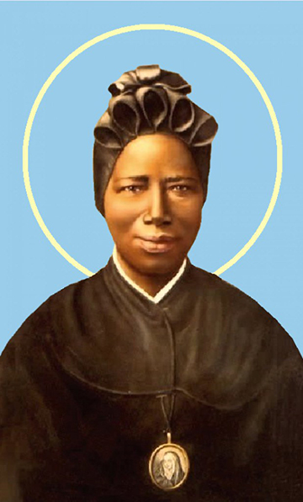

The Feast Day of St Josephine Bakhita on February 8 celebrates the patron saint of victims of modern slavery and human trafficking. It is a day when Catholics are encouraged to remember and pray for all those affected by modern slavery and human trafficking and to commit to practices (for example when purchasing) that eliminate these scourges from society.

St Josephine Bakhita was kidnapped in Africa at the age of nine and sold into slavery. Her suffering was alleviated in 1882 when she was taken to the Italian Consul. She later entered a second Italian home where she received kindness, respect, peace and joy. St Josephine entered the Canossian Sisters order and for the next 50 years was a source of encouragement to others through her constant smile, humility and simplicity. She died on 8 February 1947. St Josephine was canonised by Pope St John Paul II on October 1 2000.

Prayers to St Josephine Bakhita are included at the end of this bulletin.

It is estimated that over 40 million people are trapped in slavery globally – and that 25% of these are children. Many products we buy come from producers who use child labour and forced labour, often involving trafficked children and adults. Even if these workers are not slaves, they live and work in slavery-like conditions, which are often unsanitary and dangerous, for less than the minimum wage.
We know this situation is particularly rife in the production of coffee, tea and cocoa; it is also all too prevalent in industries like construction, agriculture and textiles to name a few. Instances of trafficking and forced labour continue to arise in Australia and in the Sandhurst diocese – they are not issues that are remote to us. Do you know if your coffee or chocolate is certified slavery-free?
While we have a legal imperative (in light of the Federal Government’s 2018 Modern Slavery legislation), there is first and foremost a moral imperative for all who work in schools and offices for Catholic Education Sandhurst Ltd to lead the way in educating members of our community to bring an end to slavery and human trafficking by making simple and practical consumer decisions. Pope Francis reminds us that ‘every person ought to have the awareness that “purchasing is always a moral – and not simply an economic – act”’. As a community we need to be thinking about our supply chains (including for labour, uniforms, and consumables such as chocolate, coffee and tea) are coming from.
Catholic Education Sandhurst Ltd is moving towards being a slavery-free organisation. In 2020 Monique (Mon) Chalker joined our team as Procurement & Contracts Officer. The three CESL Offices committed to ensuring that our staffrooms will only buy and consume tea, coffee and drinking chocolate that is certified as slave-free by Fairtrade, UTZ or Rainforest Alliance and features one of their labels. Soon we will be asking our schools to do the same.
School leaders wanting more information about their requirements under the Modern Slavery Act are asked to contact Mon Chalker (0437 831 652).
Catholic Identity & Social Justice Leaders wanting curriculum resources and support for appropriate social justice action should contact David Walker (0439 201 307).
AND ANOTHER THING ... CELEBRATING A SLAVERY-FREE EASTER

Easter will be here before we know it (Easter Sunday is April 4 this year). To ensure your Lent and Easter are slavery-free, encourage the buying of certified chocolate. Encourage staff, students and families to look for chocolate with one of these logos on it – Fairtrade, UTZ or Rainforest Alliance.
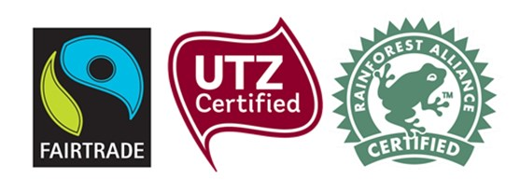
There are some slavery-free chocolates available in most large supermarkets. ALDI is the best place to start. Brands such as Haighs, Alter Eco and Green and Black’s offer a variety of choices. Fairtrade Australia and New Zealand has a comprehensive list of slavery-free certified chocolates. Find it at: http://fairtrade.com.au/Fairtrade-Products/Chocolate-cocoa
In addition
- If you are putting together a fundraising chocolate raffle for your school or workplace, or organizing Easter gifts, make sure to only include chocolate that is certified slavery-free. Consider giving the profits of your raffle to Caritas, which works to ensure people are not forced into slavery and forced labour.
- Promote the idea of a slavery-free Easter in your school newsletter
- Speak to your local supermarket about providing more slavery-free products on their shelves.
- Tell at least five other people about slavery-free chocolate and encourage them to buy it too.
- Subscribe to ACRATH to receive regular updates three or four times a year via their newsletter https://acrath.org.au/news/newsletter/ Notices for your school, parish or workplace bulletin are available on their website.
- Donate to ACRATH. Currently ACRATH receives no Government funding and values the many grants and donations from supporters and members who share their vision for ‘a world free of human trafficking’.
- A suite of fairtrade / slavery-free resources are available on the CESL Catholic Identity webpage under Social Justice – or contact David Walker (dwalker@ceosand.catholic.edu.au).

PRAYER TO ST JOSEPHINE BAKHITA
Saint Josephine Bakhita, you remained strong and brave through years of slavery. You used your knowledge and experience in helping to prepare Sisters who were going to work in Africa. Your gentle manner brought peace and strength to all. Help us to have courage when times are hard; help us to be strong and supportive to anyone in need; help us always to remain close, as you were, to Jesus, and show his love to all. Amen.

PRAYERS OF INTERCESSION
Leader: As we honour the memory of St Josephine Bakhita, the patron saint of trafficked people, let us pray that God’s freedom and justice will come for all.
Our response is: God of life, hear our prayer.

- We pray for the men and women trapped in bonded labour in fields, market gardens, mines and factories, that they will be respected as human beings rather than reduced to commodities and tools of production. God of life, hear us.
Response: God of life hear our prayer.

- We pray for an end to all discrimination, but especially discrimination against women and girls (who are estimated to make up 80% of trafficked victims), so that all may live with dignity and respect. God of life, hear us.
Response: God of life hear our prayer.

- We pray that wealthy countries like Australia may be generous in supporting impoverished nations so that all people have a decent standard of living and escape the desperate circumstances that make them vulnerable to human trafficking. God of life, hear us.
Response: God of life hear our prayer.

- We pray that our demand for cheap goods and services will be reduced so that workers’ conditions and payment will reflect the dignity of their persons and their work. God of life, hear us.
Response: God of life hear our prayer.

