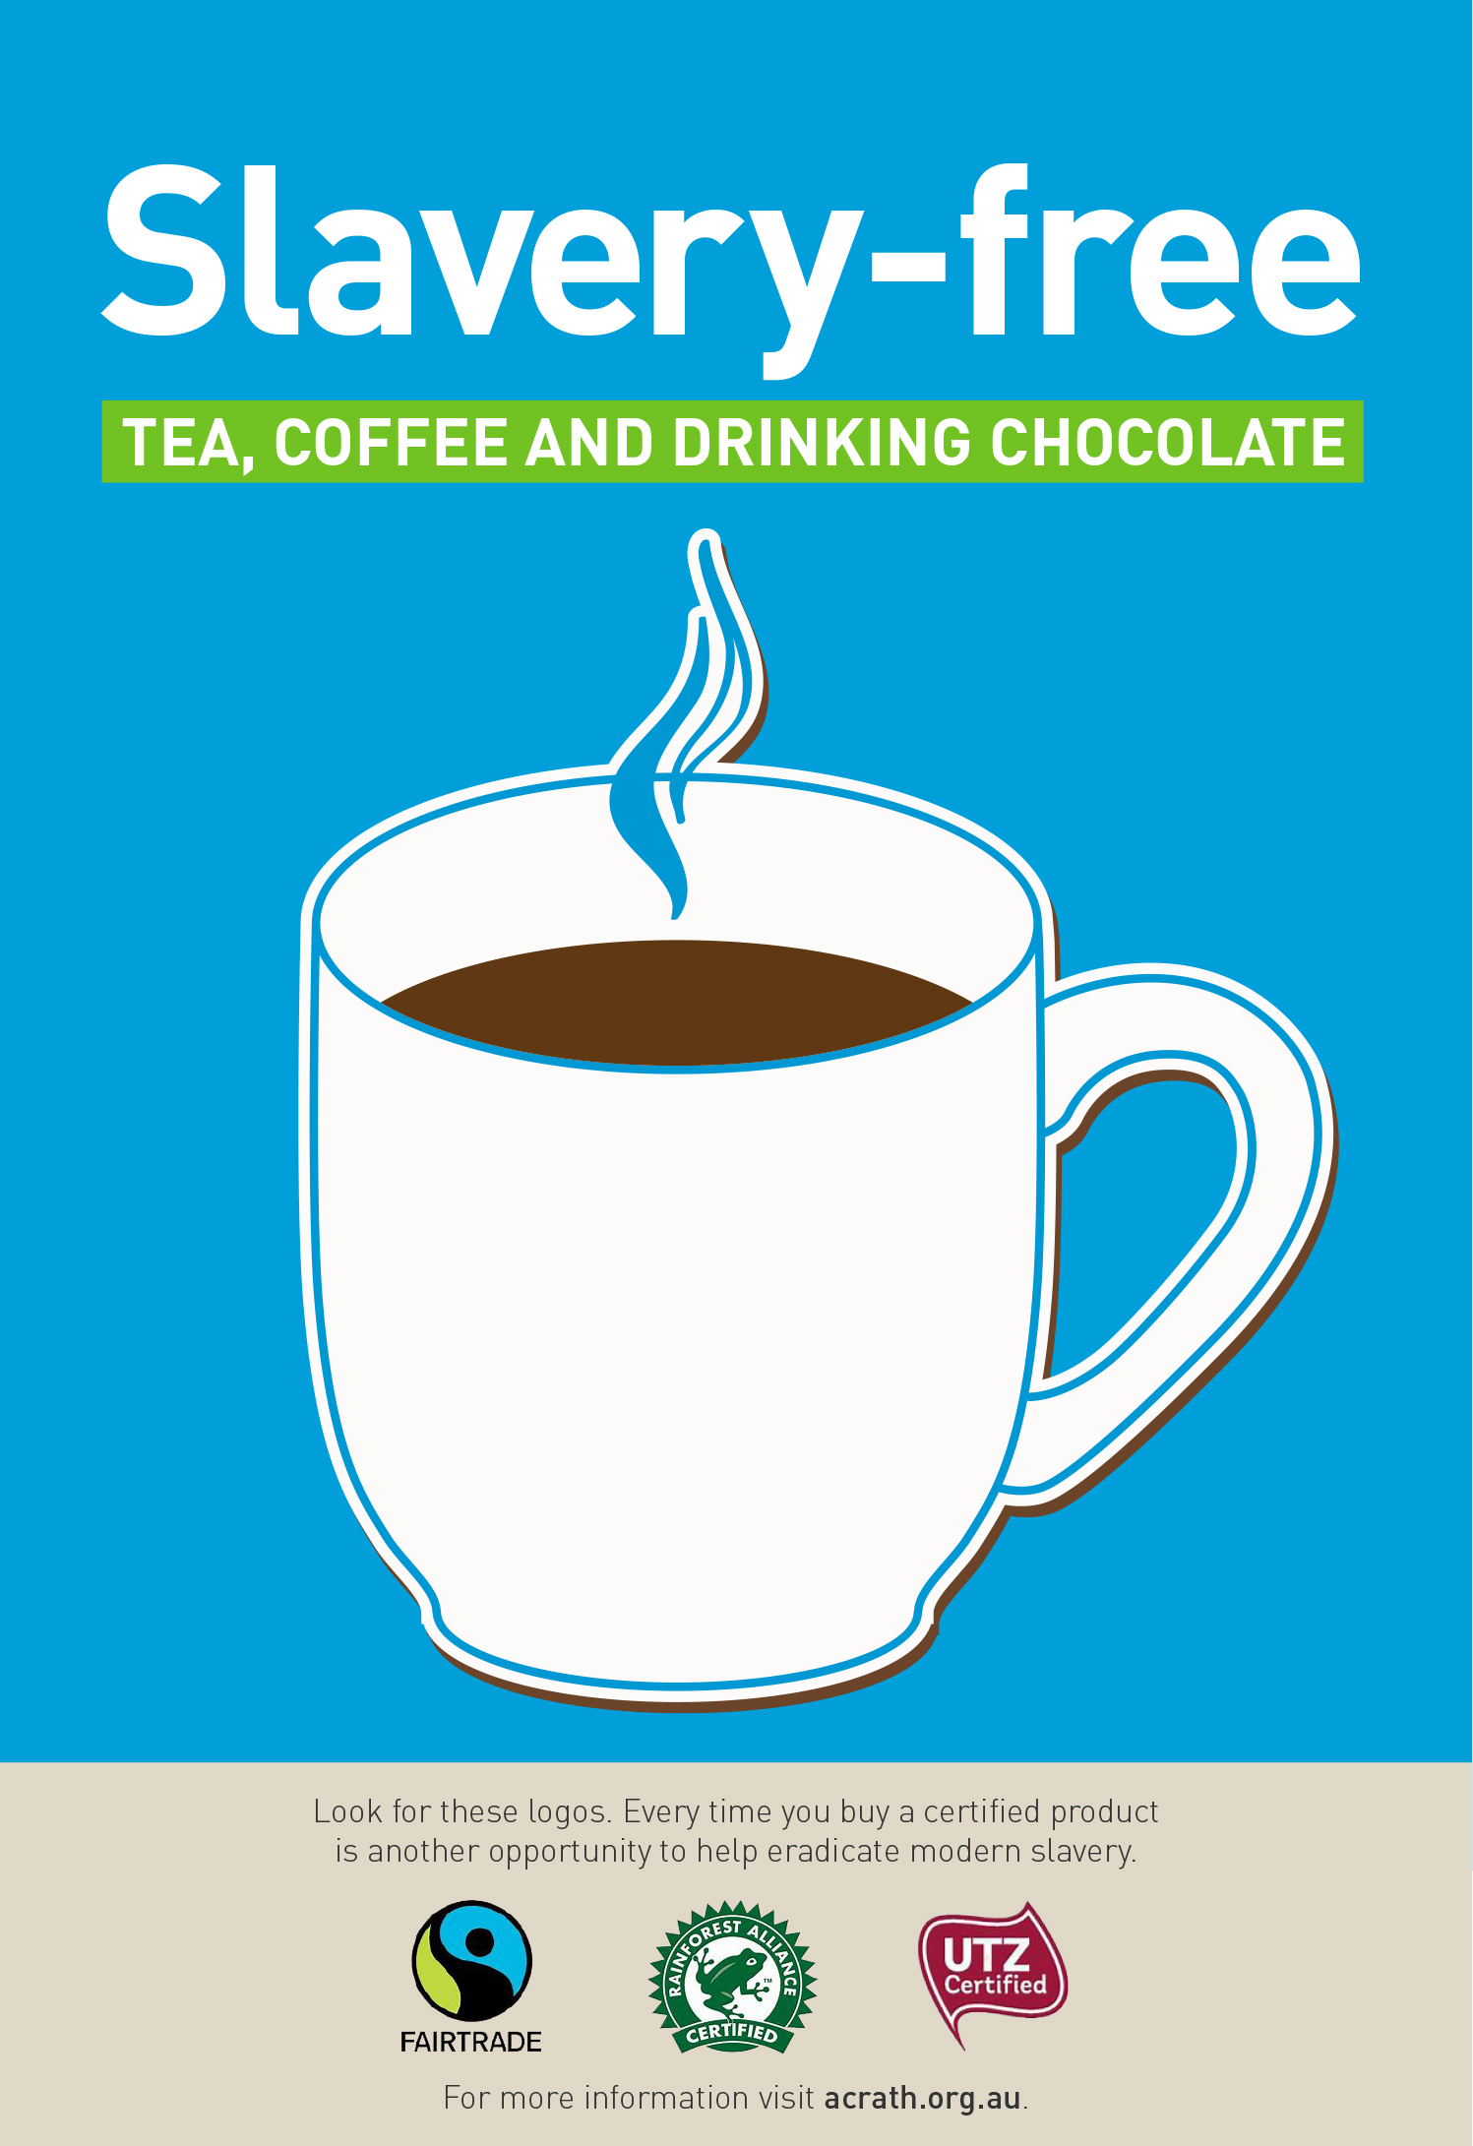
In the coming months you will notice a gradual change to slavery-free tea, coffee and drinking chocolate products in your staffroom.
Knowing that they have been produced and supplied ethically and sustainably should give you an extra pep in your step!
– <insert school name> NOW SERVING –

