
Catholic Education Sandhurst

Fair Trade Resources

What certification and why?
Many products we buy come from producers who use child labour and forced labour, often involving trafficked children and adults. If these workers are not slaves, they live and work in slavery-like conditions, often unsanitary and dangerous conditions, for less than the minimum wage.
We know this is particularly rife in the production of coffee, cocoa and tea.
At the beginning of this century there was a call for external certification as a way to improve the production and supply chains of these and other products.
External certification
Fairtrade, the Rainforest Alliance and UTZ are the main external certification systems offering independent verification of practices on the farms on which coffee, tea and cocoa are produced. All three share a similar goal of fairer labour practices and the protection of human rights throughout the supply chain.
Their standards are set independently and their auditing processes are undertaken independently by third-parties. They then offer on-product labelling for communicating with consumers at the point of sale. They all address issues of child labour and human trafficking.
However, each organisation has its own particular emphasis. Fairtrade emphasises a fair price and empowerment for farmers; Rainforest Alliance emphasises environmental factors; UTZ emphasises a market-oriented approach with farmers managing their farms profitably. Rainforest Alliance and UTZ are in the process of merging and are defining a new Sustainable Farming Standard and certification that will be rolled out in 2021.
Self-certification
A growing number of certification labels are appearing on products in stores. These need to be recognised for what they are – self-certification. Other companies have stated they are working towards being slavery-free, but they have not added self-certification labels. While it is commendable to see the direction of many major brands working to eradicate slavery from supply chains, independently audited programs are the most transparent way to achieve this.

Buying slavery-free
When making consumer decisions for your staffroom or workplace, we encourage you to ensure that the products you buy have one or more of the following certification labels.
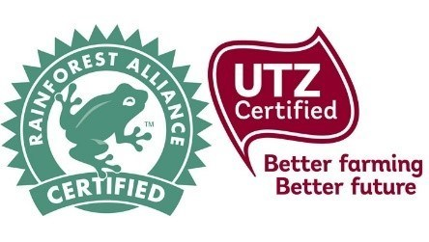
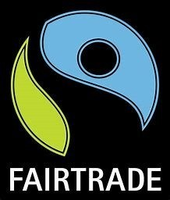

For more detail see the websites of Fairtrade, the Rainforest Alliance and UTZ. See also A Matter of Taste, which looks at chocolate manufacturers and certifiers and their role in opposing human trafficking and child labour their supply chains in West Africa.

