
Catholic Education Sandhurst

Fair Trade Resources

Sample communications
See the following examples which may be used for your school bulletin:
We are switching to slavery-free certified tea, coffee and drinking chocolate.
Pope Francis reminded us that ‘every person ought to have the awareness that “purchasing is always a moral – and not simply an economic – act”’ (Message for the World Day of Peace 2015, n. 5).
(Insert name of your school) is moving towards a slavery-free staffroom. This means that the tea, coffee and drinking chocolate we buy for the staffroom have been produced without the use of any forced or slave labour.
It is estimated that over 40 million people are trapped in slavery globally – one in four of these is a child. These people will probably never receive an education and will almost certainly never sip a latte or enjoy a cuppa in their staffroom. The buying decisions we make can change the world.
Our staffroom will now only buy tea, coffee and drinking chocolate that features one of these labels, meaning it is independently certified slavery-free.
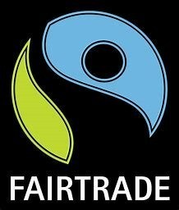
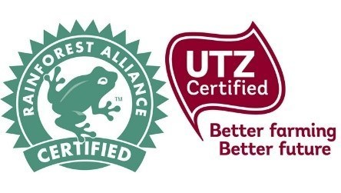

Good news: We are joining a growing number of schools to make this transition as well as Catholic Education Sandhurst, Catholic Education Melbourne and the Catholic Archdiocese of Melbourne.
Action: We encourage students and their families to follow our lead. If you want more information on our decision, or some tips on going slavery-free, please contact (insert the name of the school contact, or delete this reference to a contact person if it is not relevant). Resources are available from Catholic Education Sandhurst – contact David Walker – email: dwalker@ceosand.catholic.edu.au
(Insert date)

