
Catholic Education Sandhurst

Fair Trade Resources

Product sourcing guides
To support you in becoming a slavery-free school, below is a list of suppliers where you can purchase delicious slavery-free-certified tea, coffee and drinking chocolate for your staffroom.
Some of these sources are major supermarkets and others are smaller suppliers, and even suppliers of one type of product, e.g. coffee. Some of these are e-commerce platforms that allow you to order online.
The list will be updated as new products and suppliers are discovered. Please let us know if you come across any other products or suppliers that we can include as part of this Sourcing Guide. Email David Walker at Catholic Education Sandhurst – Email: dwalker@ceosand.catholic.edu.au with your supplier and/or product details.
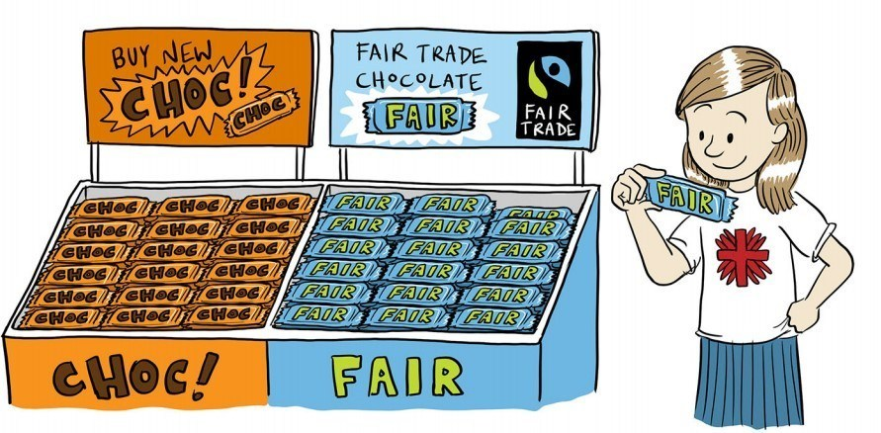

Image: James Foley/Caritas Australia

Suppliers

- Tea, coffee and coffee pods with Fairtrade or Rainforest Alliance certification

- Variety of Fairtrade products, including tea, coffee and coffee pods
Coffee
- Just Organic Fairtrade Ground Coffee
- Expressi Organic Fairtrade Coffee Pods
Tea
- Just Organic Fairtrade Green Tea
- Just Organic Fairtrade Black Tea bags
Chocolate
- Just Organic Dark Chocolate
- Just Organic Fairtrade Dark Chocolate with Sea Salt
- Choceur chocolate varieties

Fairtrade certified tea and coffee products
- UTZ certified tea products

Coffee pods compatible with Aldi, Nespresso and Caffitaly machines. These pods are Fairtrade, organic, Australian-owned and biodegradable.
Webshop: Fairtrade coffee and tea
- Business customers page, for a business discounts list

