
Catholic Education Sandhurst

Fair Trade Resources

FAQs
What does it mean to ‘make our staffroom slavery free’?
It means to change purchasing practices and buy tea, coffee and drinking chocolate that were produced without the use of slave labour or forced labour. Making your staff room slavery-free means swapping one product for another – it doesn’t mean going without.
This 90-second video from FairtradeANZ illustrates this issue.
Why is buying slavery-free products important?
It is estimated that over 40 million people globally are trapped in slavery or slavery-like conditions – one in four of them a child. Some of these are trafficked into slavery and others forced to work in appalling conditions for a pittance.
The decisions we make about what we buy can change this. By deciding to buy only products certified slavery-free, we can help eradicate child labour, forced labour and human trafficking and make a difference to the world.
How do I know that my tea, coffee and drinking chocolate is slavery-free?
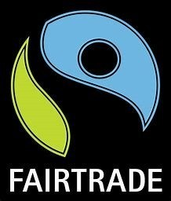
A slavery-free product will feature a small logo that indicates it is certified and meets certain standards. The most common labels are Fairtrade, UTZ and Rainforest Alliance (UTZ and Rainforest Alliance are in the process of merging). The labels look like this:
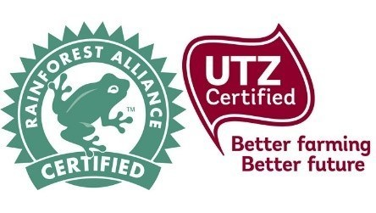

To find out more about Fairtrade products go to the Fairtrade website.
To find out more about UTZ-certified tea, UTZ-certified coffee and UTZ-certified cocoa (which is used in drinking chocolate), go to the UTZ website.
Why are slavery-free tea, coffee and drinking chocolate different from non-certified tea, coffee and drinking chocolate?
Rainforest Alliance, UTZ and Fairtrade certification aims to achieve slavery-free production of the tea, coffee and harvesting of cocoa beans for our drinking chocolate.
While they are slightly different certification programs, they have a common goal, which is to ensure the just and safe treatment of workers.
Where do we buy slavery-free products for our staffroom?
We have developed a buying guide to assist you in sourcing slavery-free coffee, tea and drinking chocolate. Please note, it does not cover every buying option.
We would love to hear from you about other sources.
For larger schools the e-commerce platforms will be helpful. Smaller schools, especially those in country or regional areas, will need to look at local supermarkets. Most of the better-known smaller supermarkets in Australia, such as IGA, carry some Fairtrade or UTZ–certified products.
Our buying guide offers online options.
Our staffroom has a coffee pod machine. Are slavery-free coffee pods available?
Yes, they are and they are delicious. Check out the options listed in the buying guide.
Will going slavery-free and buying coffee, tea and drinking chocolate that is certified UTZ or Fairtrade cost us more?
This depends on what brands you buy and in what quantities.
We have included on the CES Schools' Portal a buying guide, which provides some buying options (we will add to this over time). We suggest you go through it and compare your costs.
Feedback from organisations that have already transitioned to slavery-free products is that the transition can be cost-neutral.
Something else to keep in mind: as demand for slavery-free certified products grows, costs may come down. And it’s worth swapping!
Who else is doing this in their schools?
We know that a lot of schools and workplaces around Australia are transitioning to a slavery-free staffroom.
St Vincent’s Health Australia, across its 32 sites, is working to make their supply chains slavery free.
The staffrooms of Catholic Education Melbourne and the Catholic Archdiocese of Melbourne are going slavery-free. The Catholic Archdiocese of Sydney is also working with schools and workplaces to make this change.

