
Catholic Education Sandhurst

Fair Trade Resources

Fairtrade case studies
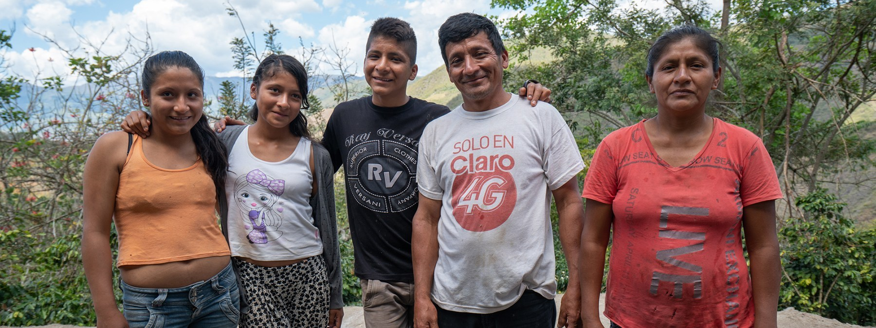

Image: Giora Dan/Fairtrade ANZ
Guzman Nunez Torres and family

Fairtrade Farmer Testimonial 1 – Guzman Nunez Torres
Fairtrade offers you the power to change the world every day
Peruvian coffee farmer Guzman Nunez Torres and his family know first-hand the benefits of being a part of the Unicafec Fairtrade cooperative in Peru. Importantly, the just income paid for their coffee has enabled his children to receive an education.
‘For sure! I’m far more financially secure. For example, if I had only the same five hectares of coffee with old [levels of] productivity … I wouldn’t get enough to even eat,’ Guzman said.
‘But now, within those same five hectares … I have been able to sustain my family, to give education to my children. I’m proud that my son has a professional career now, has finished his studies and the other ones are on the same road.’
What we choose to buy matters
The lives and education possibilities of children all around the world can be affected by what we, in Australia, choose to buy.
With simple shopping choices and by stocking Fairtrade products in your staffroom, you can get farmers in developing countries a better deal. And that means they can make their own decisions, control their future and lead the dignified life everyone deserves.
Fairtrade is about better prices, decent working conditions, sustainability, and fairer terms of trade for farmers and workers.
By requiring companies to pay fair and sustainable prices (which must never fall lower than the market price), Fairtrade addresses the injustices of conventional trade, which often discriminates against the poorest, most marginalised producers.
Fairtrade changes lives
Asked about the impact of the Fairtrade system, Guzman said: ‘There’s a visible change in front of your eyes.
‘Before, we used to work as if we were a ship in the sea with the engine turned off, adrift. You go wherever the sea or the wind takes you.
‘We worked adrift because we didn’t have support or the organisation provided by Fairtrade. It has helped a lot. Because of the training, the processes, but also because of the prices.
‘Everybody knows this is the difference and we see it now more than ever, the importance of organising the cooperative and the benefits of Fairtrade.’
According to Guzman, the increased financial security offered by the Fairtrade Minimum Price, and the investment in quality and productivity made possible by the Fairtrade Premium, has enabled him to provide a quality education for all of his children.
And Guzman has a simple message to supporters of Fairtrade in Australia:
‘If I had to tell them something, I would say to them, “be courageous and buy more of our coffee. Decide yourself, because we take care of it”.’
Guzman Nunez Torres and his wife Dionisio Ticliahuanca Facundo have five children.
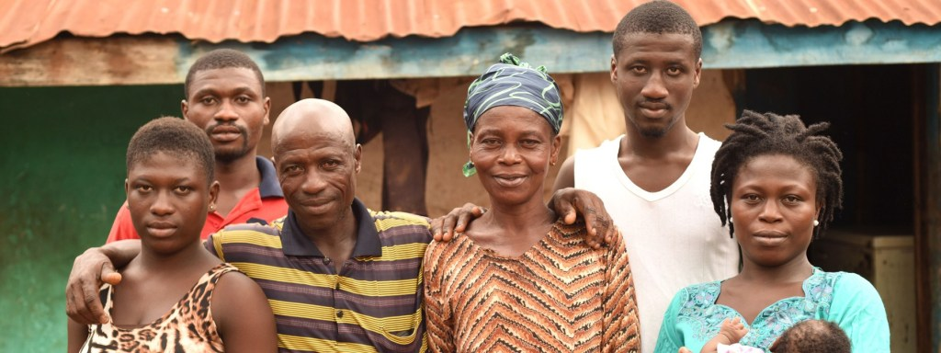
Their oldest son is an agronomical engineer working in Piura, and their second son is studying agricultural production at a technical institute in San Ignacio. Their two daughters and youngest son, Maria Socorro, Roger Wilfredo Nunez Ticliahuanca and Elizabeth Christina (pictured), are all in high school.

Image: Kate Fishpool / Fairtrade Foundation
Photo of some of Oti’s family including, his wife, Augustina Afia Atta, sons Okra Daniel and Konadu Stephen, daughter Atta Felicia and daughter Dumasi Comfort and her baby, Johnita Osei Crister.

Fairtrade Farmer Testimonial 2 – Oti Manu
Oti labours against child labour
Oti Manu has learned a lot since becoming part of a Fairtrade cooperative in Ghana.
A cocoa farmer for 15 years, Oti has eight acres of land where his involvement in the cooperative has helped him improve his yields.
Importantly, Oti feels that Fairtrade is helping people understand the importance of not using children for labour, so that they can grow, be educated and become future leaders. And he should know.
Oti and his wife, Augustina Afia Atta, have eight children and most of them are in school. One of his children is studying agronomics and another son and daughter are in senior high school.
Oti is a local cocoa facilitator from Kasapin cooperative (primary) part of Asunafo North cooperative (secondary), and he shows other farmers how to prune more effectively to help them get more yields from their farm. He also has animals on his farm.
But the benefits reach far beyond Oti and his family. Fairtrade Premium has been used to construct new school buildings in his community.
Oti feels that his main challenges are the weather and money – he needs money to be able to get labourers on his farm.
Thanks to Fairtrade Australia and New Zealand (FairtradeANZ) for their support in providing images and information.

