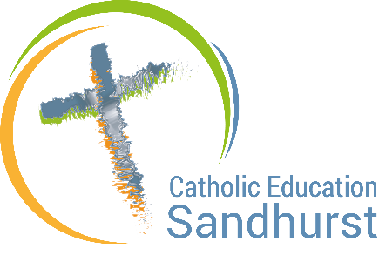
Catholic Education Sandhurst

Fair Trade Resources

Catholic Social Teaching – Why we should be slavery free
Catholic Social Teaching is based on the fundamental truth that each and every person – without exception – is made in the image and likeness of God.
Each of us, then, is imbued with an innate and inalienable dignity, which must be respected by others. Modern slavery is a direct and heinous attack upon this dignity.
In solidarity, we are all therefore called to actively and unceasingly seek to assist our brothers and sisters who find themselves the victims of the scourge of modern slavery and human trafficking.
As it is the goal of each person to do good, it is the aim of society to work towards the common good. We cannot, therefore, allow our brothers and sisters to be enslaved in the production of goods or services for our consumption.
In working towards the common good we are called to give a preferential option for the poor, ensuring we care for the poorest and most vulnerable people. Those who are trafficked and/or enslaved or who are forced to work in slave-like conditions are among the poorest and most vulnerable.
St Paul reminded the early Church in Corinth that, ‘When one suffers, we all suffer’ (1 Cor 12: 26). This admonition is as true for today’s People of God as it was for the people of Corinth.
Pope Francis, in his 2015 World Peace Day Message, reminds us of what Pope Benedict XVI wrote in Caritas in Veritate (n. 66): that every person should ‘realise that purchasing is always a moral – and not simply an economic – act’.
When, in 1537, Pope Paul III outlawed slavery (Sublimus Dei), he sought to establish for all time the Church’s opposition to a practice which St Augustine had described in these terms: ‘The condition of slavery is the result of sin’.
As Church, we the people of God ‘cannot and must not remain on the sidelines in the fight for justice. [We] have to re-awaken the spiritual energy without which justice, which always demands sacrifice, cannot prevail and prosper (Benedict XVI, Deus Caritas Est, n. 28a).

- Watch this short video over a coffee!
CST 101: Solidarity
You might also like to watch the rest of the seven-part series of videos on Catholic Social Teaching.
- See also the website of Caritas Australia for classroom resources on Catholic Social Teaching, including videos, cartoons and learning activities.

