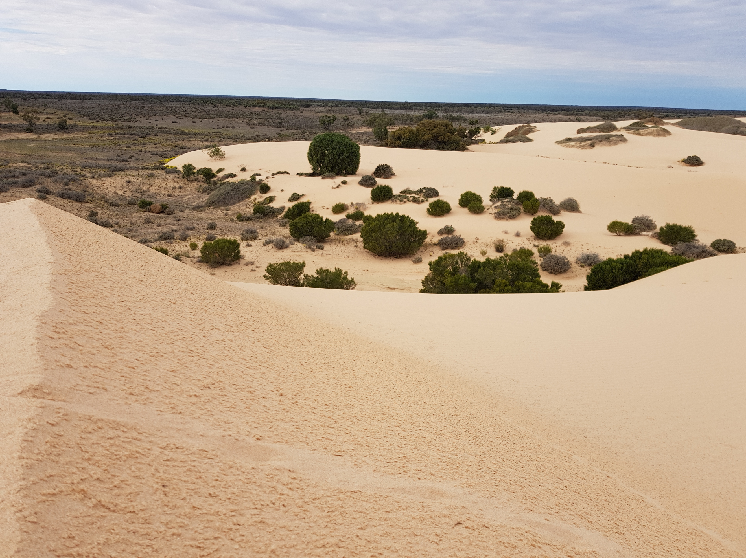

‘Shifting Sands’
Immersion
To Mildura
and Lake Mungo
October 25th – 29th 2021

Walk this ancient land

Come! You are invited to
experience Australia’s true history.
On shifting sands, connect with the ancient sacredness of Aboriginal spirituality and culture.
Walk in harmony with the land.
Be part of the presence.

You are invited by: Catholic Education Sandhurst Ltd
‘Shifting Sands’
Leaving from Shepparton

Cost: $1200.00 inclusive (transport, accommodation, meals)

Expression of interest to:
Louise Levy Education Officer Aboriginal & Torres Strait Islander Education - Bendigo
Mobile: 0447 396 074
Email: llevy@ceosand.catholic.edu.au
OR
Karen Mahoney Coordinator
Mobile: 0439 290 410
Email: kkmahoney@hotmail.com

