STATIONS OF THE CROSS
The Aboriginal Way
These Stations were prepared by the
Aboriginal Catholic Ministry, Melbourne,
Good Friday 2000.
Before using them, please seek permission.
The Last part of each station was added by
Fr Gerard Conlan OMI, 2004.

Opening Prayer
The trials of this life are the passion of Jesus in us. In ourselves and in all who suffer, Christ is in agony until the end of time. So the compassion that we feel for Christ in his passion we must also extend to all our suffering fellow human beings. Just as the contemplation of Christ crucified prompts us to ask, "What ought I do for him?, so the contemplation of humanity crucified should prompt the same question.

1
JESUS IS CONDEMNED
"He was despised and rejected by the people,
a man of sorrows and acquainted with grief." (Isaiah 53 :3)
Jesus' pain came out of his condemnation. Aboriginal pain comes out of invasion. Over the years, the pain of unjust discrimination has been born by the Aboriginal people of Australia. Today, we are so aware of this discrimination in the NT and WA mandatory sentencing laws.
For showing us the way to the Kingdom of God. R/.
R/. We give you thanks, O Lord.
For the injustice you underwent on our behalf. R/.

For your infinite mercy. R/.

2
JESUS TAKES UP HIS CROSS.
"Ours were the suffering he bore,
ours the sorrow he carried." (Isaiah 53:4)
Living out their Aboriginality, accepting their identity and culture is the burden Aboriginal people bear. As Jesus took up his cross so Aborigines have taken up the burden of their own cross by living their Aboriginality. The Assimilation policy added to this burden.
For your prayer in the Garden of Gethsemane. R/.
R/. We give you thanks, O Lord.
For your readiness to accept this suffering for us. R/.

For your persistence in doing your Father’s Will. R/.

3
JESUS FALLS THE FIRST TIME
"I am only to say ‘I am stumbling’ and you Lord,
at once support me." (Psalm 93:18)
When Aborigines are caught in racism, they fall. In spite of what has been done to them, they become as the oppressor. A change of heart will enable all of us to rise from this fall.
For your endurance before your false accusers. R/.
R/. We give you thanks, O Lord.
For your courage in proclaiming the truth. R/.

For your suffering as Christ, our Redeemer. R/.

4
JESUS MEETS HIS MOTHER.
"His mother meanwhile kept all these things in her heart."
(Luke 2.51)
As they see their children taken from them, Aboriginal mothers understand the pain of Mary. Often the birth of their babies were written into the station ledger in the following way:
Born to the station: calves - 9
lambs - 28
foals - 2
Born to H.Black and J. Mallyer: girl baby - 1.
(Ref: Over My Tracks, …)
For thinking of us in your dying moments. R/.
R/. We give you thanks, O Lord.

For the example of your devotion to your mother. R/.
For giving us your mother to be our mother too. R/.
5
SIMON OF CYRENE HELPS JESUS CARRY THE CROSS.
"On their way out they met a man from Cyrene named Simon. And the soldiers forced him to carry Jesus' cross."
(Matthew 27:32).
Aboriginal men and women were called up to fight in defence of Australia during the wars - they took up the cross beside their oppressors but enjoyed none of the privileges of the returned soldiers. They were excluded from the R.S.L., ineligible for the Land Settlement Scheme and denied the returned soldiers pension.
For the help of Simon the reluctant stranger. R/.
R/. We give you thanks, O Lord.
For letting us share the burden of your cross. R/.

For giving us the strength to lighten the burden of others. R/.
6
VERONICA WIPES JESUS' FACE.
"Lord I seek your face; do not hide your face from me." (Psalm 26:9)

One of our elders, Eleanor Harding, asleep on a cold winter's night wakes to the sound of the phone ringing. It is the police. 'Nancy is in trouble again.' Nancy insists that she has a place to stay. Eleanor accompanies Nancy. Nancy's home is a hole in the ground on a disused building site. Eleanor takes Nancy home with her. She has wiped the face of Christ.
For imprinting your love into our hearts. R/.
R/. We give you thanks, O Lord.
For the care and love that is shown by others. R/.
For calling us to be your witnesses in the world. R/.
7
JESUS FALLS THE SECOND TIME.
"Down in the dust I lie prostate: revive me as your word has guaranteed." (Psalm 118:25).
Wik! Our hopes are alive. The highest court in the land has found in our favour. Almost immediately the government, miners, landowners start a campaign to whittle away the intent of the High Court's Wik decision. We are crushed. We fall again.
For the care you have shown to us. R/.
R/. We give you thanks, O Lord.
For helping us to get up when we fall. R/.

For opening the Kingdom of God to us. R/.
8
JESUS MEETS THE WOMEN OF JERUSALEM.
"Daughters of Jerusalem, do not weep for me. Weep for yourselves and your children." (Luke 23:28).
What has it profited white Australia to have gained the whole of Australia and yet to have suffered the loss of its collective soul? Australia is a nation struggling for identity; for family, harmony and security; for ecological sustainability. Do not feel sorry for Aboriginal people who live in harmony with one another and the land. In the words of the Aboriginal Our Father, "Others have done wrong to us, and we are sorry for them, Father, today."
For your compassion in your hour of pain. R/.
R/. We give you thanks, O Lord.
For your calling to us to come to you. R/.
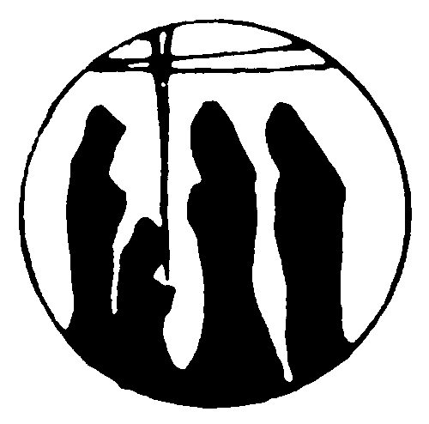
For your concern for us despite our failings. R/.
9
JESUS FALLS THE THIRD TIME.
"Though the virtuous fall. He shall not be bitterly cast down." (Psalm 36:28)
Greg is an alcoholic. He tries to straighten himself out. Greg goes to Galliamble - a halfway house. It is managed by an elder, Richard Ambrose. Greg 'busts' several times. Richard always takes him back. Finally, Greg is discharged. His first child is born. Greg 'busts' again. He arrives back at Galliamble looking for help. The directors are tired of Greg. They tell him he is not welcome. He has 'busted' too many times. Richard persuades them to take him back. Greg is now a recovered alcoholic and a good family man.
For bearing the burden of our sins. R/.
R/. We give you thanks, O Lord.
For carrying the cross on our behalf. R/.

For raising the weight of our offenses. R/.
10
JESUS IS STRIPPED OF HIS CLOTHES.
"They divide my garments amongst them, cast lots for my clothes." (Psalm 21:18)
Mrs Wirrapunda is being cross-examined by a trained lawyer. In her own simple way, she is trying to prove that her Yorta Yorta people have a right to their land by the river. The lawyer introduces a tape recording of her deceased mother and father's voices. He has not asked her permission. It is completely taboo for the voice of deceased people to be used this way. But, the lawyer has no knowledge and little respect for Mrs Wirrapunda's culture, laws and customs. Just as Jesus is stripped, so are Aboriginal people stripped of their identity and culture.
For suffering humiliation for our sake. R/.
R/. We give you thanks, O Lord.

For your hours of agony for our redemption. R/.
For the healing power of your Message. R/.
11
JESUS IS NAILED TO THE CROSS.
"All who see me, jeer at me; they toss their heads at me." (Psalm 21: 7)
At five you laughed at my culture.
At fifteen you called me dirty.
At twenty-five you took away my freedom.
At thirty-five you broke my spirit.
For your forgiveness of the repentant sinner. R/.
R/. We give you thanks, O Lord.
For offering us pardon in our sinfulness. R/.

For calling us all to your eternal Kingdom. R/.
JESUS DIES ON THE CROSS.
12
"They have pierced my hands and feet; I can count all my bones. They look on me and gloat over me: they divide nay garments among them, for my clothing they cast lots." (Psalm 22:17-19)
We were killed on our land.
We were killed on the streets.
In the cells our dignity was killed.
When will the killing stop?
(Pause for reflection music at this station)
For the agony of your dying. R/.
R/. We give you thanks, O Lord.
For the final sacrifice of your life. R/.
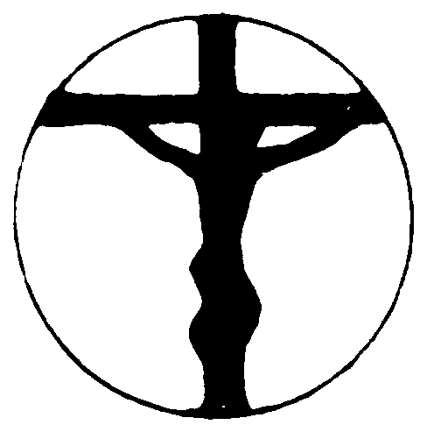
For the new life given to us by your death. R/.
13
MARY HOLDS JESUS' DEAD BODY.
"Standing close to Jesus' cross was his mother." (John 19:25)
Mary, an Aboriginal woman, takes her sick child to the manager. She is refused proper care for her child. Without the required permit, Mary took her sick child to the hospital. The child died. Mary asked to see her babe but the hospital refused. Mary pleaded and searched the hospital to find her babe. She found her baby in a banana box out the back of the hospital.
For your perseverance on the cross. R/.
R/. We give you thanks, O Lord.
For the strength you give us in our time of need. R/.

For your great act of mercy toward us. R/.
THE BURIAL OF JESUS.
14
"They have taken the Lord and we don't know where they have put him." (John 20:26)
At the time of the invasion of Victoria in 1830, the Aboriginal population was already decimated by the spread of diseases. This was followed by massacres and malnutrition. By the late 1800's their number had dropped from an estimated 200,000 to 2,500. (Koorie)
For the humility of your death and burial. R/.
R/. We give you thanks, O Lord.
For giving us eternal life. R/.
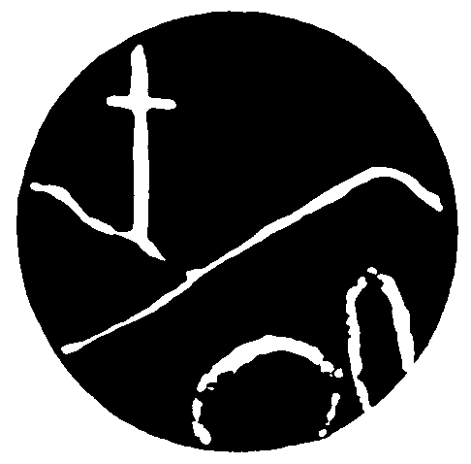
For the example of caring shown by Joseph of Arimathea. R/
SPIRIT RISING.
15
"He is not here, he has risen." (Mark 16:6)
Eddie Mabo died before he saw the result of his fight for recognition of his ancestors but his name in history will live on. Through the Mabo claim, the Australian nation was freed from living the lie of 'terra nullius' - Australia was an empty land. Many Aboriginal people have died in the fight for recognition. They too will live on.
CONCLUDING PRAYER
Having relived again the passion, death and resurrection of Christ, our Redeemer, let us now go forth filled with the joy, the hope and the peace that He gave us when He spoke to His apostles:
“Do not let your hearts be troubled
Trust in God still, and trust in me.
There are many rooms in my Father’s house;
if there were not, I should have told you.
I am going now to prepare a place for you
and after I have gone and prepared you a place,
I shall return to take you with me;
so that where I am, you may be too.”

Note:
Contact made with Aboriginal Catholic Ministry in early March, 2004 to use the stations.

Contacted again on 1st April, 2004, and received permission to modify the text by replacing the song at each station with a responsorial verse.

e-mailed to [acmvicki@optusnet.com.au] for their info.

