FOREWORD
This is the second version of “Dreaming in the City” sponsored by Aboriginal Catholic Ministry Melbourne. Along with the paintings and reflections we have included the following:
- How to pray the rosary
- The four sets of Mysteries listed as
  - Joyful or Happy Stories paintings and reflections
  - Light Stories paintings and reflections
  - Sorrowful or Sad Stories paintings and reflections
  - Glorious or Wonderful Stories paintings and reflections
- Four reflections on each set of mysteries/stories
Praying the Rosary Aboriginal way has resulted in a reflective process of painting and story telling which links the gospel stories upon which this traditional form of prayer is based, with the historical and contemporary experience of urban Aboriginal people. It is an expression of one aspect of what we call ‘city dreaming’. The Glossary is a useful tool for better understanding of the Aboriginal cultural and spiritual terminology used in the Rosary Reflections.
Gum nut Rosary beads are available at:
Aboriginal Catholic Ministry,
434 St Georges Rd., Thornbury 3071,
(03) 9480 3849
Email vicki.clark@cam.org.au

Vicki Clark,
ACMM Coordinator
FIVE step rosary process
Praying the Rosary the Aboriginal Way

Welcome
Leader welcomes the group and explains why the gathering is
taking place. (To grow strong among ourselves as we talk and
pray together about things that matter to us.)

Acknowledgement of Country
Leader to prepare and present a suitable statement

Rosary Stories
We choose one of the four stories: either Happy, Light, Sad or Wonderful to pray together. We pause for a brief reflection before saying the prayers.

HAPPY Stories
Joyful Mysteries

LIGHT Stories
Luminous Mysteries

SAD Stories
Sorrowful Mysteries

WONDERFUL Stories
Glorious Mysteries

Rosary reflection
Leader will select a reader/s to lead the reflection.
HAPPY Stories
The story begins with a young Jewish girl who, during the period of her waiting to go to her promised husband, becomes pregnant. Mary was a special young girl who kept the law well when, without warning, a Spirit Messenger came to her. “Hello, Mary! Don’t be frightened. I have come with a great message for you. It is time for the special one promised by the God of your ancestors to come into the world. This child is to come for all clans and all peoples, to show them how to find their way back to the Creator and their true country.”
When the Spirit Messenger told Mary that her cousin Elizabeth was also pregnant Mary decided to visit her because she was a wise and respected elder. On arriving she found that the Spirit had given her cousin the knowledge of her child. Mary sang a song, one that came from deep within her, an ancient song passed on from one of her ancestors of long ago. Mary’s promised husband grew to understand that her child was the one the wise ones in his culture had been telling his people about for many generations. He knew that he was to be named Jesus.
When Mary’s baby was born the story was first told in the stars, Aboriginal understanding of the movement of the stars through the evening sky is profound. The presence of particular stars or groups of stars at certain times gave information about food sources, ceremonial events, and reinforcement of moral issues. The Wandjina of the Kimberleys are very well known and important sky figures. The Creator Spirit of Western Victoria, Bunjil, is present in and watching his people from the star Altair.
Soon after the child Jesus was born, he was taken to a special place to be presented for a ritual blessing. We recognise in this event some aspects of Aboriginal birthing rites. A mother takes her newborn baby to a special place and performs a ritual of great importance established by each group’s own law. Natural symbols of water, oil, ashes, wind, earth and smoke are used. A birthing ritual creates within the child a deep inner sense of place, belonging and identity within family and community.
Sometime later when Mary and Joseph were travelling home from a special ceremonial gathering, Jesus could not be found. They searched among their clan groups but he was not there. Days later, they found him sitting with the elders and lawmen, talking deeply with them about law and culture. The elders were surprised at his knowledge. They recognised that he was ready to be initiated into the beginning of his spiritual journey as a young man. Going away from family is the beginning of Aboriginal initiation too. These times are not without pain mingled with joy for both family and child, as the experience leads to strength and growth.
Happy stories
The Angel visits Mary
The Annunciation

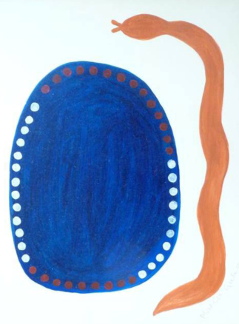
1 Mary is an ordinary girl. Her people have been waiting a long time. She is a bit worried and needs an explanation. Her belief brings great happiness. This painting shows Mary’s womb rich with blood for her baby. The serpent is a sign of life and fertility.
The Spirit of this Child Jesus overshadows the oppressed Aboriginal Culture of this land. We must believe and trust like Mary.

Happy stories
Mary visits Elizabeth
The Visitation

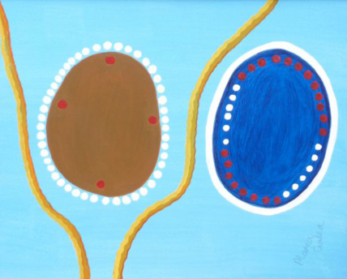
2 Mary rushes to see Elizabeth. They are cousins. Mary sings an old song and Elizabeth’s baby jumps with gladness. Both women believed. The Spirit is strong in both of them.
Mothers and children are very close. Today mothers are nourished by participation in supportive groups.

Happy stories
Jesus is born
The Nativity

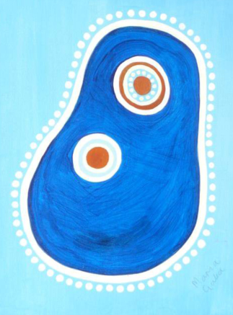
3 After a lot of trouble, Mary has her baby in someone else’s place. They are poor but happy. The whole of creation is happy.
Many Aboriginal people have been born in places far away from their own Country. The land is our mother and like a human mother our Land takes care of us and we take care of it.

Happy stories
The baby Jesus is presented by Simeon
The Presentation

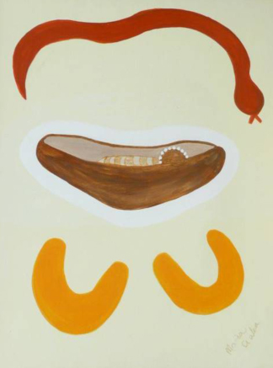
4 This story is about the beginnings of life. Jesus’ parents kept the law. They took him to the Jewish elders in the temple.
Aboriginal people want their children baptised “good one way”. Often Aboriginal children are baptised with a Smoking Ceremony.

Happy stories
Jesus is found in the Place of Worship
The Finding of the Child Jesus in the Temple

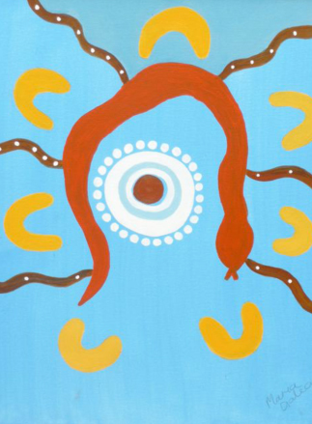
5 Jesus is talking with the elders. Both his questions and his answers show that he is wise.
Aboriginal children are taught to listen very early. Later when they are older they learn their Culture from the strong teaching of the wise elders. Jesus was not yet ready to teach God’s message to the world.

Happy stories

About Artist
Maria Galea is a descendent of the Gunditjmara people. This series of paintings observes that there is something shining in Maria’s insights.

Rosary reflection
Leader will select a reader/s to lead the reflection.
LIGHT Stories
These new mysteries of Light given us by Pope John Paul 11, were given to us to renew and refresh us in their importance to our prayer life, as we rush through our lives with increasing speed and forgetfulness. Many consider this form of prayer to be no longer needed. In fact it is needed more than ever. If we do not find a way to slow down we will all become insane. Many other cultures find this praying on beads very therapeutic.
This is what Aboriginal People of the past were very skilled at doing. Things were never hurried. Much time and thought went into making decisions. This is a gift we must bring into the new Jesus Dreaming. Our way of being less materially minded and returning to our connectedness to the earth and nature are further ways of creating peace and harmony to our troubled lives.
Jesus said, “Come and see”. This is what Aboriginal People can offer to the Church and others: simple liturgies, more quiet and space to reflect on what we are doing. Sometimes our rituals are so overcrowded with words and activities we become lost in the hype. We need to bring more of our symbols, stories and songs to our Eucharistic celebrations also. Where people are using our Message Stick and Coolamon, there is renewed interest. Our welcome and acknowledgement of land and its people must not fall into being merely quick rhetoric.
So the need for these new Light stories can help us to become the mystics we once were. Christianity needs us. Perhaps a name change could help young moderns such as “the Beads of Mystery”.
light stories
Jesus is baptised
Baptism of Jesus

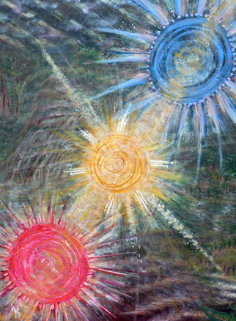
1 When it was time, Jesus asked his cousin John, to baptise him in the Jordan River. At first John didn’t want to - he thought Jesus should baptise him – but then he agreed. As Jesus came out of the water He heard his Father’s voice saying: You are my Son, the One I love. John the Baptist and Jesus introduced a new rite of Baptism, immersing people in the River Jordan. This was a symbol of dying to the old way and rising up to New Life.
Earth, fire, water, oil and smoke are used in Aboriginal birthing ritual and ceremony. The Spirit, who is with the child from conception, gives the child a strong relationship to the Dreaming, Country, Law, Kinship, and Culture. We, too, are given a relationship with God at our Baptism when we draw on our ways of tradition and culture, maintaining a life-giving connection to the environment.

light stories
Jesus’ first miracle at the Cana wedding
Jesus changes Water into Wine at the Wedding Feast of Cana

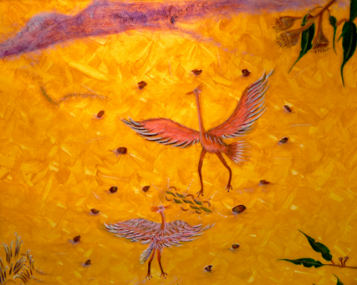
2 At a wedding in Cana, the hosts ran out of wine. Jesus’ mother wanted him to do something about it but Jesus said it wasn’t their business and it wasn’t the right time. But then he told the waiters to fill six jars to the brim with water. This water came out as very good wine – the head waiter was very surprised and Jesus’ followers believed in him. This was the first of Jesus’ signs.
Commitment to each other in marriage is commitment of Land and Law continually woven in the marriage. Kinship celebration with damper, storying, corroboree and song, around the camp fire, lasts many days. There is an emerging awareness of the need for a living spiritual system to bind couples together to honour the sacredness of the eternal pattern of Marriage.

light stories
Jesus teaches and heals us
Proclamation of the Kingdom

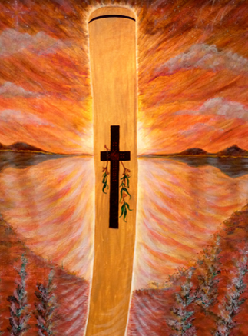
3 At the beginning of his public life, Jesus moved from Nazareth up to the Sea of Galilee, to a town called Capernaum. It was safer for him there. Here he began telling the people the good news of God’s Kingdom. Here, he also called four fishermen to follow him. They were Simon Peter and Andrew who were brothers and James and John who also were brothers. When Jesus called them, they left their boats and nets and immediately went with him.
Aboriginal cultural symbols speak to us of the Kingdom: circle, pathway, bush animals, fish, the eagle…. The Great Creator gave us the way to live through creation stories and song symbolized in the Message. The Creator intends us to care for the Land and all Creation, to act justly, to love tenderly and to walk humbly with our God. However we keep stumbling and getting lost.

light stories
Jesus shows He is Divine
Transfiguration

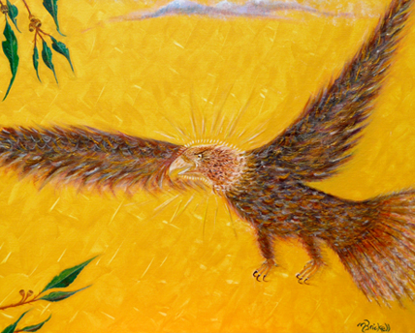
4 One day Jesus took Peter, James and John up onto a high mountain where he became shining white and Moses and Elijah appeared and talked with him. Peter and the others were very frightened. Something like a cloud came down and covered them all. They heard a voice from the cloud, saying: This is my Son, the One I love. Listen to him.
The story of Mulinthin, when his transfigured, shining face appeared, it amazed his people. “Who’s that?” they said. Mulinthin’s broken spear became clap sticks. Mulinthin transformed his life from war to peace.

light stories
Jesus gives us His Body and Blood
Jesus institutes the Eucharist

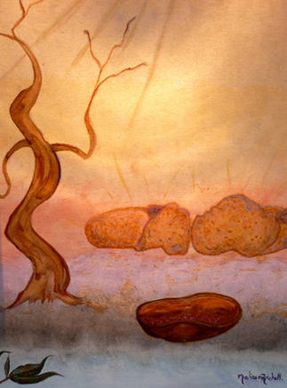
5 “Do this in memory of Me” was Jesus’ final instruction to his disciples. How could they eat his Flesh and drink his Blood? Jesus places emphasis on food partaken in a human relationship with others, bonding and strengthening the group. Through the power of the Spirit Eucharist sustains us on our Life’s journey
Changing of the bread and wine into the Body and Blood of Christ recalls the power and energy source of our Creator Spirit through the trees, grasses, rivers, seas, bush animals, fish, birds, stars, heavens and all of us on earth.

light stories

About Artist
Melissa Brickell Yorta Yorta & Wiradjeri Clans
Melissa began painting landscapes in 1976, then gave up to ‘grow up’ her family. Twenty years later Melissa began to paint again for the Aboriginal Catholic Ministry Melbourne. Much of her artwork but not all has been for the Catholic community. Her artworks include acrylic on canvas, candles, message sticks and plaques. “Painting is a passion for me, so every opportunity I get is an opportunity to be creatively passionate!”

Rosary reflection
Leader will select a reader/s to lead the reflection.
SAD Stories
As time went on and Jesus began travelling through his country telling stories to those who were able to listen to him, some skilled clever fellas became jealous of his special power in leading people. These clever ones began thinking about getting rid of him.
Our people know a lot about these clever ones, the Kadaicha, who have an evil spirit in them and have power to harm others. They are cunning and make it hard sometimes for people to recognise the bad spirit in them. The people have to listen and watch very carefully. These sorts of people can bring great trouble among the family groups.
In his heart Jesus knew what these evil ones were up to and felt afraid of the terrible things that could now happen to him. Taking some of his close friends with him, he went to a quiet place to be still and share his deep pain with the Creator Spirit. Like his mother before him, he listened deeply and said his yes to the Creator’s plan. A Spirit Messenger came to give him the strength he needed.
Jesus now began his walk through the scheming of a false trial, followed by a beating, being mocked, ridiculed and crowned. He then suffered the agony and physical pain of a cross. His final humiliation was to be stripped and to die in shame.
Aboriginal women would identify strongly with Mary as she stood by the cross. How many times have they faced the soul destroying pain and humiliation of seeing their sons mocked, abused, subjected to demoralising interrogation, tried by unfair laws, chained, beaten and thrown into jail? Many of these sons are so broken in spirit they finally end up taking their own lives.
It seemed now that all was ended. The chosen friends who had walked and listened to Jesus were a very sad and disillusioned group. They were also afraid of what could happen to them. They stayed together hiding in a quiet place till things settled down.
SAD stories
Jesus suffers in the garden
The Agony in the Garden

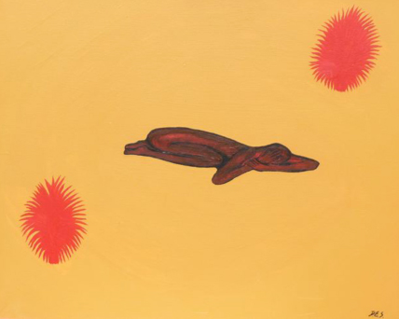
1 Jesus is lying in the garden. He is feeling despair. His mind and body are in agony. He is helpless.
Most Aboriginal people did not understand the ways of the people who took away their land and families. They were often mocked, shamed and felt disconnected, lonely while living on the fringes of society. Like Jesus they suffered these things even when they tried to help others.

SAD stories
Jesus is whipped
The Scourging at the Pillar

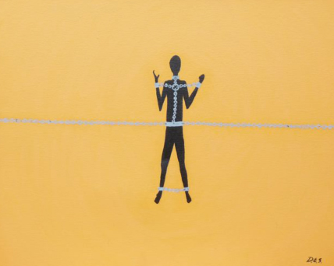
2 Jesus is carrying the suffering of the people he was close to. He is being treated like the woman who was stoned.
Aboriginal people are taken into custody and beaten up for fun. This story reminds us of the pictures of our people in chains.

SAD stories
Jesus is crowned with thorns
The Crowning with Thorns

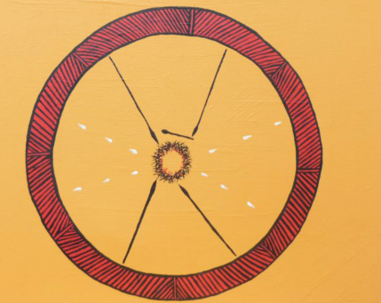
3 The soldiers make fun of Jesus. He is alone. There is no escape. He was mocked because he told the truth. He really was a king.
Many of our people are caught in situations where there is no escape. Often at these times, they are alone and they feel a great deal of shame. They are shamed like Jesus was shamed.

SAD stories
Jesus carries His Cross
The Way of the Cross

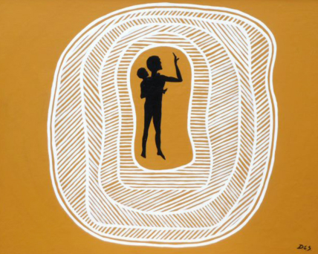
4 The cross that Aboriginal people carry is the colour of our skin. Our children carry the same cross.
The early settlers were like the soldiers who led Jesus. They sent the Aboriginal people away, making them refugees in their own country.

SAD stories
Jesus dies
The crucifixion

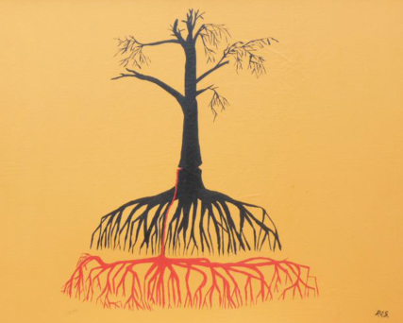
5 Jesus was killed because he was a good man.
The sap pouring out of the ringbarked tree is the blood of our people pouring out of their veins. Sacred Trees have been cut down. Jesus did not need to die; neither did the trees.
What legitimised the death of Jesus, legitimised the death of Aboriginal Culture. Many Aboriginal peoples’ lives have been stopped, yet there is always hope.

SAD stories

About Artist
Doug Smith is a descendant of the Mutthi Mutthi tribe of Lake Mungo south western NSW. Doug’s paintings represent the suffering and death of Jesus.

Rosary reflection
Leader will select a reader/s to lead the reflection.
WONDERFUL Stories
In the next part of the Rosary story we learn that sad and sorry times do not last forever. If we listen strongly to the Jesus Dreaming law, very special Spirit times can occur. The great Creator Spirit sent Jesus to tell us the greatest story of all. It is a simple yet powerful story, one that says if we believe his law of love and keep it strong, just as we kept the old law, we will not die forever but will live again.
Jesus spoke first to the women, telling them to go at once to his close friends and followers with this good news. Of course, some did not believe the women. Then Jesus himself came to his friends, talking and eating with them.
Finally, Jesus returned to his own true country with the Creator. He told his friends and followers not to worry. They would not be left alone. The Spirit would come who would stay with them always. Again they waited together till the special ceremony time the Jewish people called Pentecost. This was a time of thanks for good seasons and plenty of food.
Mary stayed with the followers of the New Way for many years until it was time for her to go to her true Dreaming place with the Creator and her son Jesus. She is the mother of God.
wonderful stories
Jesus rises from the dead
The Resurrection

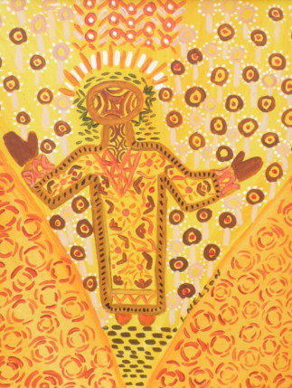
1 When the women went to Jesus’ grave, He was gone. Then they remembered. They were very excited and went to tell the others. They didn’t believe them and in a hurry, they went to see for themselves.
For good to prevail we must try to understand each other and put away our fears before we are all destroyed. This means forgiving the past and being sorry.

wonderful stories
Jesus goes up to Heaven
The Ascension

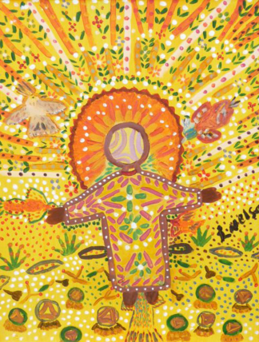
2 Jesus’ friends were frightened after he went away, yet they were strong in their faith.
Our people have known joy in suffering and happiness in hard times. Through faith we stay strong.

wonderful stories
The Spirit comes to the disciples
The Descent of the Holy Spirit

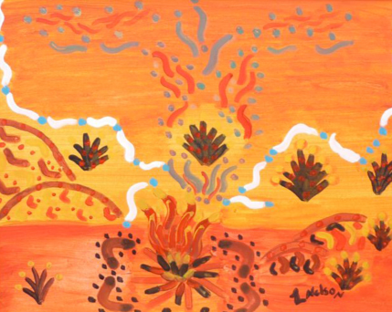
3 Like Mary, our faith in Jesus keeps us strong to survive. When Mary died she was with Jesus again. The followers of Jesus never imagined Jesus would survive his death, even when he said he would.
This is our Dreaming. Our people overcome death, and survive in the Dreaming.

wonderful stories
Mary’s body is taken up to Heaven
The Assumption

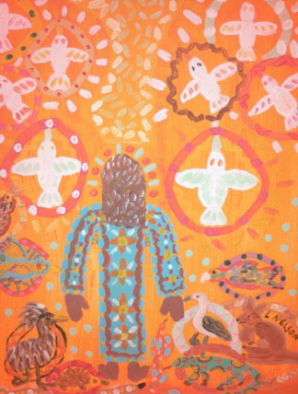
4 Mary had the strength to survive and the strength to believe. When she died she was with Jesus again.
This story is about the end of life. It is about surviving.

wonderful stories
Mary is crowned Queen of Heaven
Coronation of the Blessed Virgin Mary

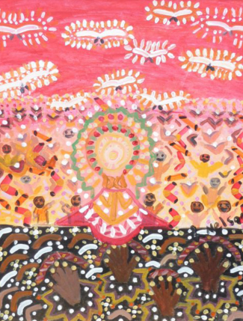
5 Mary is crowned mother of Jesus and mother of all creation.
This is a Dreaming story. All of creation is present. There is pain in the story and also hope. The moon gives us strength, the stars our guiding light.

wonderful stories

About Artist
Lorraine Nelson is one of Stolen Generations of Victoria. Lorraine is the proud mother of three children and her paintings represent the resurrection of Jesus and the coming of the Holy Spirit.

our stories reflection
Do we have stories like these? Dreaming stories or stories of today? Of what do these stories remind us? Are there any connections running through these stories?

staying strong & having our say
In what ways are these stories asking us to stay strong today?

we pray
As we pray we think about what we have shared in the group.

Sign of the Cross
I belong to the Father
I belong to the Son
I belong to the Spirit

we pray
As we pray we think about what we have shared in the group.

Aboriginal Our Father
Our Father You are in heaven
May we talk about Your name in a good way.
May You be Boss in our lives.
May we follow Your feeling here
As they do above.
Give us bread today.
We have hurt Your feelings, feel sorry for us.
Others have hurt our feelings, we feel sorry for them.
Stop us from doing wrong.
Save us all from the evil one.
we pray
As we pray we think about what we have shared in the group.

Hail Mary
Hello Mary,
You are truly good in your heart,
You are with the Lord.
Of all women you are truly good.
Good is your Son, Jesus.
Good Mary, Mother of God,
Pray for us when we have done wrong
Right now and when we fall down.

we pray
As we pray we think about what we have shared in the group.

Gloria
Praise the Father
Praise the Son
Praise the Spirit
Praise them Three in One.
Acknowledgements
Sponsored by: Binnap Partners, Aboriginal Catholic Ministry Melbourne (ACMM)
General Editor: Vicki Clark
Photographer: Christine Valladares
Aboriginal Flag Design: Harold Joseph Thomas
Creative Design: Fraynework, Barry St, Carlton
Production Editors: Members of ACMM
Writers: Mrs Elizabeth Pike, members of ACMM
Artists: Lorraine Nelson, Maria Galea, Doug Smith (1997) and Melissa Brickell (2011)
Aboriginal Prayers: Bidyadanga Community, Kimberleys
Scripture and notes: Christian Community Bible. Catholic Pastoral Edition, Claretian, Philippines
Publisher: Aboriginal Catholic Ministry Melbourne
PO Box 1088, Thornbury, 3071
Phone: 9480 3849
Fax: 9480 2163
Email: vicki.clark@cam.org.au and sherry.balcombe@cam.org.au

©Copyright Aboriginal Catholic Ministry Melbourne. All rights reserved

Cover Picture
Rosary Beads gathered and created from gum nuts by Sr. Helen-Mary Langlands fcJ and friends at Aboriginal Catholic Ministry Melbourne. The Cross is Australian timber resting on an Australian Aboriginal Flag.

