Pry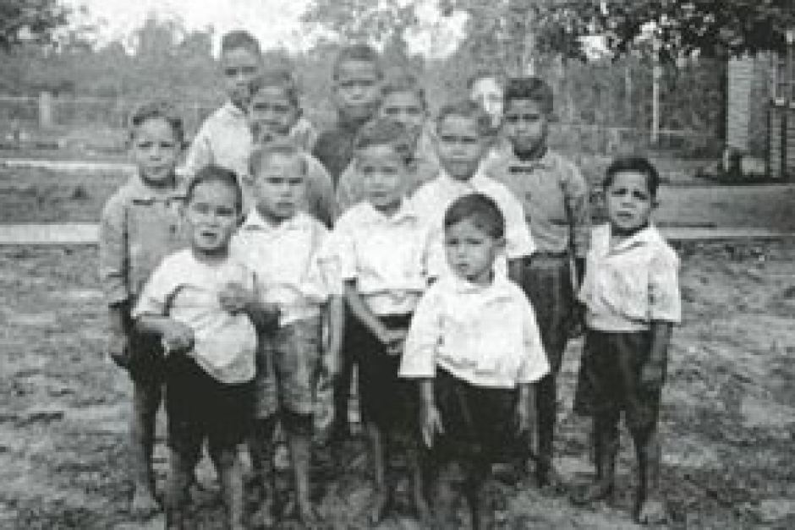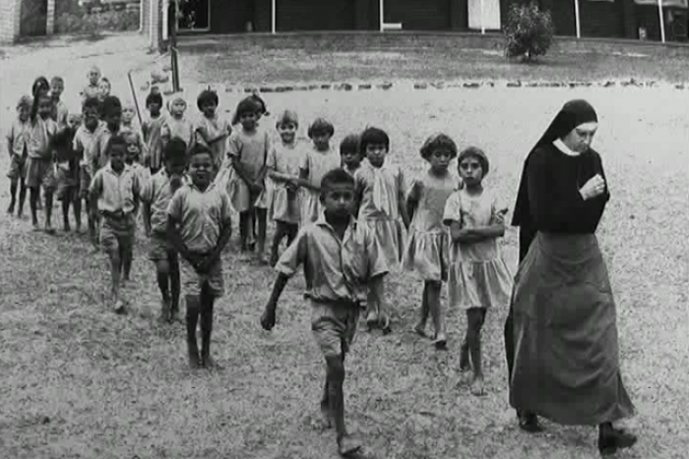er
PRAYER
God created human beings to have unique characteristics and purpose.
The Readings tell us we should be rooted and built up in Christ. Where you have your roots is where you get your nourishment to keep going. He designed us also to have a commonality of contentment with our lives through His will. We discover our true identity the more closely we are drawn to Him.

a

THE CHILDREN CAME BACK ADAM BRIGGS

I'm Fitzroy where the stars be
I'm Wanganeen in '93
I'm Mundine, I'm Cathy Free-
Man, that fire inside-a-me
I'm Adam Goodes, and Adam should
Be applauded when he stand up
You can look to us when that time stop
I'm Patty Mills with the last shot
I'm Gurrumul, I'm Archie
I'm everything that you ask me
I'm everything that you can't be
I'm the dead hearts, heart beat
The children came back
The children came back
Back where their hearts grow strong, back where they all belong
The children came back
I'm Doug Nicholls, I'm Jimmy Little
With a royal telephone
I'm the world champ in '68
Boy I'm Lionel Rose
I'm William Cooper, I take a stand
When no one even knows
I'm the walk off, I'm the sound of
The children coming home

Boy I'm Gurrumul, I'm Archie
I'm everything that you ask me
I'm everything that you can't be
I'm the dead hearts, heart beat
The children came back
The children came back
Back where their hearts grow strong, back where they all belong
The children came back
Let me take it home, I'm Rumba
I'm the sand hills on Cummera
I'm Les Briggs, I'm Paul Briggs
I'm Uncle Ringo with all them kids
Im Uncle Buddy, everybody loves me
Ain't none below, ain't none above me
Im the carvings outta every scar tree
I'm those flats that birthed Archie
Now Mr Abbott, think about it
Me and you we feel the same
That might sound strange, I'm just sayin'
We both unsettled when the boats came
I'm Gurrumul, I'm Archie
I'm everything that you ask me
I'm everything that you can't be
I'm the dead hearts, heart beat
The children came back
The children came back
Back where their hearts grow strong, back where they all belong
The children came back
The children came back
The children came back
Back where they understand, back to their mothers' land
The children came back
The children came back
The children came back
Back where their hearts grow strong, back where they all belong
The children came back

1 John 3:1
1 See what great love the Father has lavished on us, that we should be called children of God! And that is what we are! The reason the world does not know us is that it did not know him.
2 Dear friends, now we are children of God, and what we will be has not yet been made known. But we know that when Christ appears, we shall be like him, for we shall see him as he is.

Romans 15:7
7 Accept one another, then, just as Christ accepted you, in order to bring praise to God.

1 Corinthians 6:17
17 But whoever is united with the Lord is one with him in spirit.

Genesis 1:27
27 So God created mankind in his own image, in the image of God he created them; male and female he created them.

Jeremiah 1:5
5 “Before I formed you in the womb I knew you, before you were born I set you apart; I appointed you as a prophet to the nations.”

1 Corinthians 12:27

27 Now you are the body of Christ, and each one of you is a part of it.

Galatians 3:27-28

27 for all of you who were baptized into Christ have clothed yourselves with Christ. 28 There is neither Jew nor Gentile, neither slave nor free, nor is there male and female, for you are all one in Christ Jesus.

1 Corinthians 6:19-20

19 Do you not know that your bodies are temples of the Holy Spirit, who is in you, whom you have received from God? You are not your own; 20 you were bought at a price. Therefore honour God with your bodies.

Colossians 3:1-3

1 Since, then, you have been raised with Christ, set your hearts on things above, where Christ is, seated at the right hand of God. 2 Set your minds on things above, not on earthly things. 3 For you died, and your life is now hidden with Christ in God.

God of life,
I thank you for your presence with me;

I thank you for your presence in me;

I thank you for protecting me;

I thank you for providing for me;

I thank you for empowering me.

Grant that I always live in light of my identity in Christ, as I work to proclaim your Gospel. I make this prayer through Christ Our Lord. Amen

