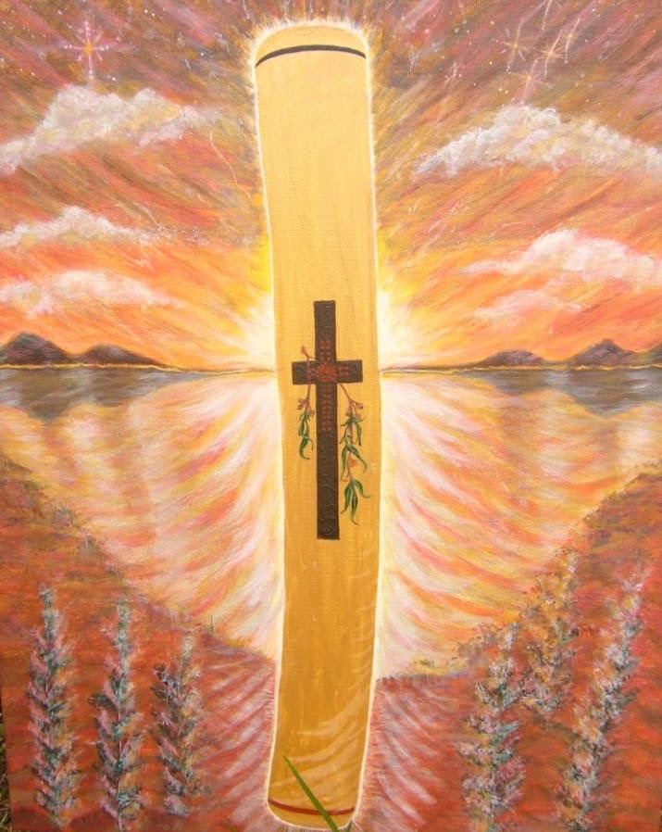
Prayer of the Aboriginal People
Father of all,
You gave us the Dreaming
You have spoken to us through our beliefs.
You then made your love clear to us in the person of Jesus.
We thank you for your care
You own us, you are our hope.
Make us strong as we face the problems of change.
We ask you to help the people of Australia
To listen to us and respect our culture.
Make the knowledge of you grow strong in all people,
So that you can be at home in us and we can make a home
For everyone in our land.
Amen.

