Let us Pray
Ode to a Gathering Place

We walk barefoot to the gathering place
Of our own true country
To a space embraced by our Creator.
There our hearts can grow in the stillness.

Then by the Spirit we are nurtured
And the hidden spring within us is revealed,
It’s waters fusing with our very being,
Making us one with the silence,
The mystery and wonder of all creation.

Then in the quiet of the night
The silent music of the stars fills us,
And we hear the whisperings of the sacred songs,
Another revelation of the Spirit
Gently saying,
“All is of the ancient Dreaming.”
A Morning Reflection

I wake in the morning
from the velvet softness of the night
In the name of silence
the place of our true belonging.

I awake in the morning
and bless all things –
the wonder of light
that brightens the dawn,
the breath of the air
the cool intimacy of its touch
as the Spirit enters my soul.

I awake in the morning
and my heart sings,
as I see the fresh beauty
of the colours in the heavens
bringing the eternal close
to the heart and soul
of the land.

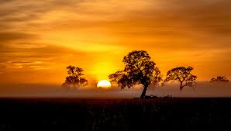

The Power of Story- Poems, prayers and reflections

