Anniversary of the National Apology 13th
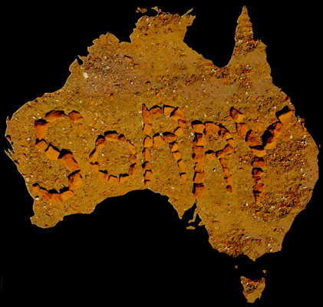
Rational:
Please Note: Elements of this Liturgy may be integrated into a Eucharistic Liturgy or Para- Liturgy or adapted for Class Prayer and reworded for year levels.

This liturgy is to give life to the sacred gift given by the Victorian Aboriginal Catholic Ministry that enhances the significances of the Holy Scriptures and prayer as we remember that on this day Friday the 13th nine years ago the former Prime Minister of this country Kevin Rudd said Sorry to Australia’s first people:
Preparation: A planned relay of the Message Stick needs to be scheduled so the Message Stick can be relayed across as many class rooms as possible for a short prayer.
What happens if you don’t have a Message Stick?
There are no Message Sticks in stock at the ACM so the liturgy could be simply used over the PA as Morning Prayer or elements of the liturgy could be used during assembly.
2 readers are required
Prepare a resting place for the Message Stick in the class room your school may have soil or ashes from Mungo Immersions, gums leaves, clap sticks coolamons etc.
Liturgy over the loud speaker as Morning Prayer across all class rooms and as an introduction to Message Stick.
Play Clapsticks our didgeridoo music
Student:
Reader 1: In the name of the Father and of the Son and of the Holy Spirit.
All: Amen.
Student:
Reader 1: In the custom of our school we acknowledge the traditional custodians of
this land and pay our respects to the elders past, present and future
for they hold the memories, the traditions, the culture and the hopes
of Australia. We must always remember that under the
concrete and asphalt, of our school, was and always will be traditional
Aboriginal land.
We pay respect to them on whose land we now are,
acknowledging the loss of lands, cultures and treasures; knowing
the consequences for people, communities and nations; and
believing we can walk together to a better future.
Opening Prayer:
Student:
Reader: Creator Spirit of all,
We come to you united as your children.
May you comfort all those whose history on this land is a story of
hurt and pain.
May your wisdom and guidance be with all who work towards a
future of unity, reconciliation and peace within this Great South
Land of the Holy Spirit.
We ask this prayer in the name of your Son Jesus Christ,
All: Amen.

Student:
Reader 2: On this day 13th February 1998 the former Prime Minister of this country Kevin Rudd said Sorry to Australia’s first people:
The following is read by student or downloaded from https://www.youtube.com/watch?v=b3TZOGpG6cM
“I MOVE that today we honour the Aboriginal and Torres Strait Islander peoples of this land, the oldest continuing cultures in human history.
We reflect on their past mistreatment. We reflect in particular on the mistreatment of those who were Stolen Generations—this blemished chapter in our nation’s history.
The time has now come for the nation to turn a new page in Australia’s history by righting the wrongs of the past and so moving forward with confidence to the future.
We apologise for the laws and policies of successive Parliaments and governments that have inflicted profound grief, suffering and loss on these our fellow Australians. We apologise especially for the removal of Aboriginal and Torres Strait Islander children from their families, their communities and their country
For the pain, suffering and hurt of these stolen generations, their descendants and for their families left behind, we say sorry.
To the mothers and the fathers, the brothers and the sisters, for the breaking up of families and communities, we say sorry.
And for the indignity and degradation thus inflicted on a proud people and a proud culture, we say sorry.”
Please pause before you read
Student:
Reading 1: Isaiah 61:8-9New International Version (NIV)
⁸ “For I, the Lord, love justice;
I hate robbery and wrongdoing.
In my faithfulness I will reward my people
and make an everlasting covenant with them.
⁹ Their descendants will be known among the nations
and their offspring among the peoples.
All who see them will acknowledge
that they are a people the Lord has blessed.”
Great if clips could be viewed in class rooms
Song Secondary schools. https://www.youtube.com/watch?v=3EQrjnq3a5g
Song Primary schools: https://www.youtube.com/watch?v=xvRFvSt3JAA
Student:
Leader: Empower us Creator God,
to honour the history of this Great South Land,
to remember the story of those who have gone before us
and to ensure the future is one of peace, reconciliation
and harmony for all who walk this land.
All: Amen.

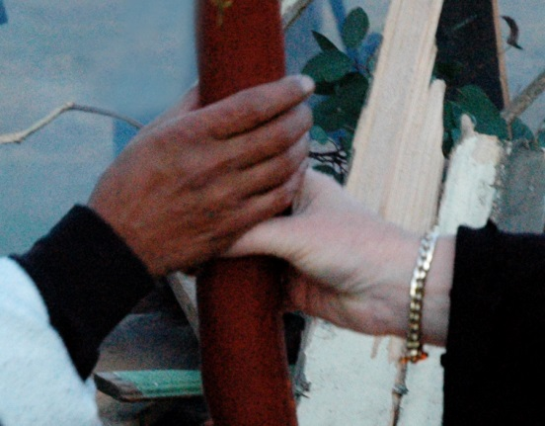
Message Stick Procession liturgy
All stand as the Message Stick arrives into close room. (If you have clap sticks they could be played as the Message Stick enters.
We say together:
Our school has been gifted with this sacred Message Stick from the Aboriginal people that symbolises a powerful message of reconciliation, forgiveness, love, hope and peace.
As Custodians of this Message Stick we understand the great privilege of being entrusted with this sacred symbol and the importance of treating the Message Stick with reverence at all times.
We give thanks to the Aboriginal people for trusting us to use the Message Stick with integrity in our liturgies.
Student:
Leader:
Most of us could never imagine what it would be like for our homes and
our land and even our family to be taken away from us and people
treated with such disregard. That is the story of this country’s past. Let
our prayer be that this story not be repeated now or in our future.

Let us pray together
Hail Mary
Hello Mary,
You are truly good in your heart
You are with the lord.
Of all women you are truly good
Good is your Son, Jesus.
Good Mary, Mother of God
Pray for us when we have done wrong
Right now and when we fall down. (Written by Bidyadanga Community, Kimberley)

All Stand:
Message Stick is placed in the resting place or processed out to the sound of clap sticks

This liturgy has been prepared by Vicki Clark in support of the Proud Race and FIRE Carriers programs
Some material from the 2016 LiturgyPrayerRitual.com and Emmaus Productions © has been used.

