Celebration of the Fire of the Living Spirit

INTRODUCTORY RITES

Priest: In the name of the Father, and of the Son and of the Holy Spirit

Priest: The grace of our Lord Jesus Christ and the love of God and the fellowship of the Holy Spirit be with you all

All: And also with you

Penitential Rite:
A rite of water blessing: It is customary in some areas, when Aboriginal people gather for important ceremonies to use water.
Water to the Aboriginal people is always a sign of God’s peace and fulfilment in everything that is good. The promise of food, of harmony with ourselves, and the bush around us.

Reader: Lord, make us feel your invitation to ‘come to the water’. At the very beginning you blessed the water, your great gift to us, and now we ask that your blessing be renewed in this water here today. We ask that through this water blessing we will all be renewed with your love, and protection, and your power to love one another as true Christians. Lord, this truly is a sign of the new life in Christ, which in Baptism we have all received.
We ask this through Jesus the Wise One.

All: Amen

Opening Prayer

Priest : Great Spirit – Father of us all, Creator of all Things.
Whose love sets no boundaries.
Give to our present leaders the strength and determination
To protect the innocence of all children and let their hearts burn with a fiery
vision to guide the world into paths of loving, justice and peace.
We ask this through your Son Jesus Christ.

All: Amen
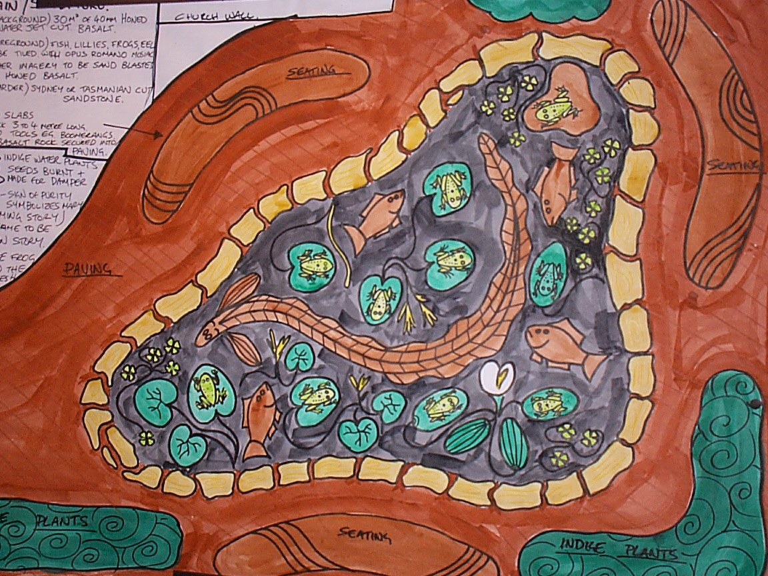
Reading: How Water was first created
adapted from a story from the Aborigines of Lake Tyers.

At one time there was no water anywhere on the face of the earth. All the waters were contained in the body of a huge frog, and men and women could get none of it.
A council was held, and the wisest amongst all the animals enquired into the circumstances connected with this extraordinary drought. It was found without doubt that the monster Frog had within himself all the waters that should have covered water places on the earth and if the Frog was made to laugh (Kramban) the waters would run out of his mouth, and there would be plenty in all parts.
It was agreed that an effort would be made to cause the monster Frog to laugh. Several animals danced and capered before him, but he remained as solemn and stupid as any ordinary Frog, even when their gestures were sufficient to arouse joy, laughter everywhere. All the animals tried and failed. At length, No-yang (the Eel) began to wriggle and distort himself, and the Frog’s jaws opened. He laughed outright. When He laughed, all waters came out of his mouth.
(This story is significant to St. Mary’s Fountain’s visual as the area surrounding the Northern Suburb’s is bordered by the Merri Creek which contains many Frogs, eels and fresh water fish and many indigenous plants such as water lilies.)

Response Yil Lull Composed by Joe Geia

I sing for the black and the people of this land
I sing for the red and the blood that was shed
I sing for the gold and the new year, young and old.

Yil lully, yil lully Yil lully, yil lully

I sing unto him of the Most High
And I sing so much praise it makes me want to cry
Now I’m singing for just you so all can recognise

Yil lully, yil lully

Everybody sing -Yil lully, yil lully

Sing for the black
Sing for the red
Sing for the gold
Sing for the young and old
The stories told

Yil lully, yil lully ( Repeated )

Gospel procession
The Message Stick can be carried forward (and upright) with the Gospel. It is held upright during the Gospel reading.

Gospel Acclamation
Clap sticks
Halle, halle, halle, lujah!
Halle, halle, halle, lujah
Halle, halle, halle, lujah
Hallelujah, hallelujah!

Gospel
(An adaptation from the Gospel of John by the Aboriginal Catholic Ministry) John 14 : 1-4

God said: “Do not let your hearts feel troubled. Trust in the Creator Spirit and trust in me. There are many places for our people in the Dreamtime. If this were not true, I would have told you. Many of your Ancestors have made these places and I will make one too. When I have made this place, we will call you back. Your Ancestors will be there and I will be there too. I have always watched over you and I am your Dreaming too. Come with me and I will show you the way to your Sacred Dreaming Place.

Reflection

Creed:
Priest: Do you believe in God, the loving Father Creator of this sacred land and all of us, God’s people?

All: We do

Priest: Do you believe in God the Son, Jesus, who became human and died so we might live forever. Jesus, who inviters all Indigenous people of Australia to “accept his words and values into their own culture” and so become more than ever truly Aboriginal?

All: We do

Priest: Do you believe in God, the Holy Spirit, who has inspired Indigenous people of this great south land through their Dreaming and who inspires us through God’s Church?

All: We do

Priest: This is our faith. This is the faith of the Church.
We are proud to profess it in Christ Jesus our Lord.

All: AMEN

Prayers of the faithful

Celebrant: On this day of celebration, we acknowledge Aboriginal and Torres Strait Islander peoples throughout Australia. We acknowledge the spiritual and Cultural contributions they make to the life of the Church.

Reader: We pray for truth, justice and healing of this great south land. May the unfinished business of Indigenous peoples have their voice, equity, and clear paths to move all Australians closer to a reconciled country. WE SEEK THE POWER OF THE SPIRIT

ALL: Lord hear our Prayer.

Reader: We pay for his Holiness Pope Benedict XVI, Bishops, Clergy and Religious and all Church leaders. May the Creator guide their wisdom and courage to good decision. May they inspire and lead the world in love and peace for all. WE SEEK THE POWER OF THE SPIRIT

ALL: Lord hear our Prayer.

Reader: We pray for the World Youth Day pilgrims and travellers. May the celebrations be guided by the Creator Spirit to lead them to love, peace and joy in their travels in Sydney; and safe journey home. WE SEEK THE POWER OF THE SPIRIT

ALL: Lord hear our Prayer.

Reader: We pray for the sick and dying, the homeless and imprisoned the weary and lost, and for those whose anniversaries occur at this time. We pray for compassion, healing, wellbeing and protection for those who are suffering. WE SEEK THE POWER OF THE SPIRIT

ALL: Lord hear our Prayer.

Celebrant: We pray Almighty God, as your people, we seek the power of your Spirit. we bring these prayers of needs before you in perfect trust and confidence. Through Christ our Lord.

All Amen

Lord’s Prayer

Chorus: You are our Father, You live in heaven,
We talk to you, Father, you are good.
You are our Father, You live in heaven,
We talk to you, Father you are good.

We believe your word, Father,
We your children give us bread today.
We believe your word, Father
We your children give us bread today.

We have done wrong, we are sorry
Help us Father not to sin again.
We have done wrong, we are sorry
Help us Father not to sin again.

Others have done wrong to us
And we are sorry for them, Father, today.
Others have done wrong to us
And we are sorry for them, Father, today.

Stop us from doing wrong, Father,
Save us all from the evil one.
Stop us from doing wrong, Father,
Save us all from the evil one.

Chorus: You are our Father, You live in heaven,
We talk to you, Father, you are good.
You are our Father, You live in heaven,
We talk to you, Father you are good.

All: For the kingdom, the power and glory are yours, now and forever.

Rite of Peace

Priest: Lord Jesus Christ, you said to your apostles:
I leave you my peace, my peace I give you.
Look not on our sins, but on the faith of your Church,
And grant us the peace and unity of your Kingdom
Where you live for ever and ever.

All: AMEN

Priest: The peace of the Lord be with you always

All: And also with you

Priest: Let us offer each other the sign of peace.

Lamb of God

O Lamb of God, O Lamb of God, O Lamb of God, I come.
You died for me, And for the world, for you are the Lamb of God.

O Lamb of God, O Lamb of God, O Lamb of God, I come.
You died for me, And for the world, for you are the Lamb of God

REFLECTION SONG

Old Streets of Fitzroy

Oh those city lights are drivin’ me crazy
As I walk the lonely streets of old Fitzroy
How I wish that I was back there in the Dreamtime
In the country where there’s always peace and quiet.

Chorus : Oh I wish that I was back in the Dreamtime
Hear the didjeridus a-dronin’ in the night.
Where the corroborees are seen by the firelight
Far away from the glow of city lights .

Now Gertrude Street, it makes me feel so lonely
For the gumtrees and the taste of porky-pine
I see my brothers and my sisters here in Fitzroy
Torn apart by government ways and city life.

Yes. city lights are driven’ me crazy
As I walk the lonely streets of old Fitzroy
I know someday that I’ll be
Called back to the Dreamtime
Where the white man’s ways
Won’t bother me no more.

Priest: Final Blessing

HEARTS ON FIRE

We come from ancient Dreamtime
From the bush, or by the sea.
We come from a thousand city streets
We are the rich and lowly,
We are the poor and strong
We come to share this moment
Gathering here, singing one song.

With our hearts on fire with the love of Jesus,
Dreaming from the heart, Let’s spread the Word!
Dreaming from the Heart, Feel the Spirit b lazing!
Dreaming from the Heart, Called to live the Good
News in this land…
Dreaming from the Heart. With our hearts on Fire
Dreaming from the Heart.

We long to live in freedom.
We yearn for unity.
We dream of justice, joy and peace .
Spirit fill us with your power.
Jesus help us live your call,
O Creator give us wisdom
So we will be Good News for all.

With our hearts on fire with the love of Jesus,
Dreaming from the heart, Let’s spread the Word!
Dreaming from the Heart, Feel the Spirit Blazing!
Dreaming from the Heart, Called to live the Good
News in this land…
Dreaming from the Heart. With our hearts on Fire
Dreaming from the Heart.

We are the voice of Jesus
We are his heart and hands
We are his Body in our land
Stand up! Live this story! To all the world proclaim
Go out to all creation
Lighting the fire, fanning the flames

With our hearts on fire with the love of Jesus,
Dreaming from the heart, Let’s spread the Word!
Dreaming from the Heart, Feel the Spirit Blazing!
Dreaming from the Heart,
Called to live the Good News in this land…
Dreaming from the Heart. With our hearts on Fire
Dreaming from the Heart.

Adapted from “Hearts on Fire” by Michael Morgan

