Liturgy Planning for Message Stick Reception

For thousands of years the Aboriginal People used the message stick as a way of communicating across country. Symbols or markings were engraved or painted to tell of Sacred Ceremonies, asking permission to cross the country of another tribe with different totems and lore. Today the Aboriginal Catholics carry the Message Stick with the bible, symbolising the respect for cultural differences when spreading the Good News.
Before you Begin  When your Liturgy Planning group meets for the first time it is important for the group to take a moment to reflect on the great privilege of being entrusted with this sacred symbol of the Aboriginal people, the Message Stick, before embarking on the practicalities of liturgy planning.  Respecting Ancient Dreaming Aboriginal people graciously share their story and culture with all people and in return we respect their Ancient Dreaming which has existed for over 40,000 years. We respect that which has gone before the birth of Christ our Redeemer and respond to the call to be united in love as one human family.  Unity in Christ We have been given the privilege of using the Message Stick as a symbol of our unity with peoples who are created by the Creator Spirit in unity with the Christ the Redeemer and sustained by the all embracing Spirit  The Privilege of using the Sacred Symbol of another Culture We understand the great privilege of being entrusted with this sacred symbol and the importance of treating the Message Stick with reverence at all times.  Gratitude We give thanks to the Aboriginal people for trusting us to use the message stick with integrity in our liturgies.  Respecting the Dignity of Others In all liturgies, ceremonies and gatherings the dignity of Aboriginal people will be respected.  When using images and music this disclaimer must always be on any printed /visual material:  Disclaimer: Some photos may contain voices and images of members of the Aboriginal community who may have returned to the Dreaming. They are used with the greatest respect and appreciation.  Acknowledging the Spirituality of Others We acknowledge the rich spirituality of the Aboriginal people through liturgies, ceremonies and gatherings that reflect the reconciliation, forgiveness, love, hope and peace of Christ our Redeemer.  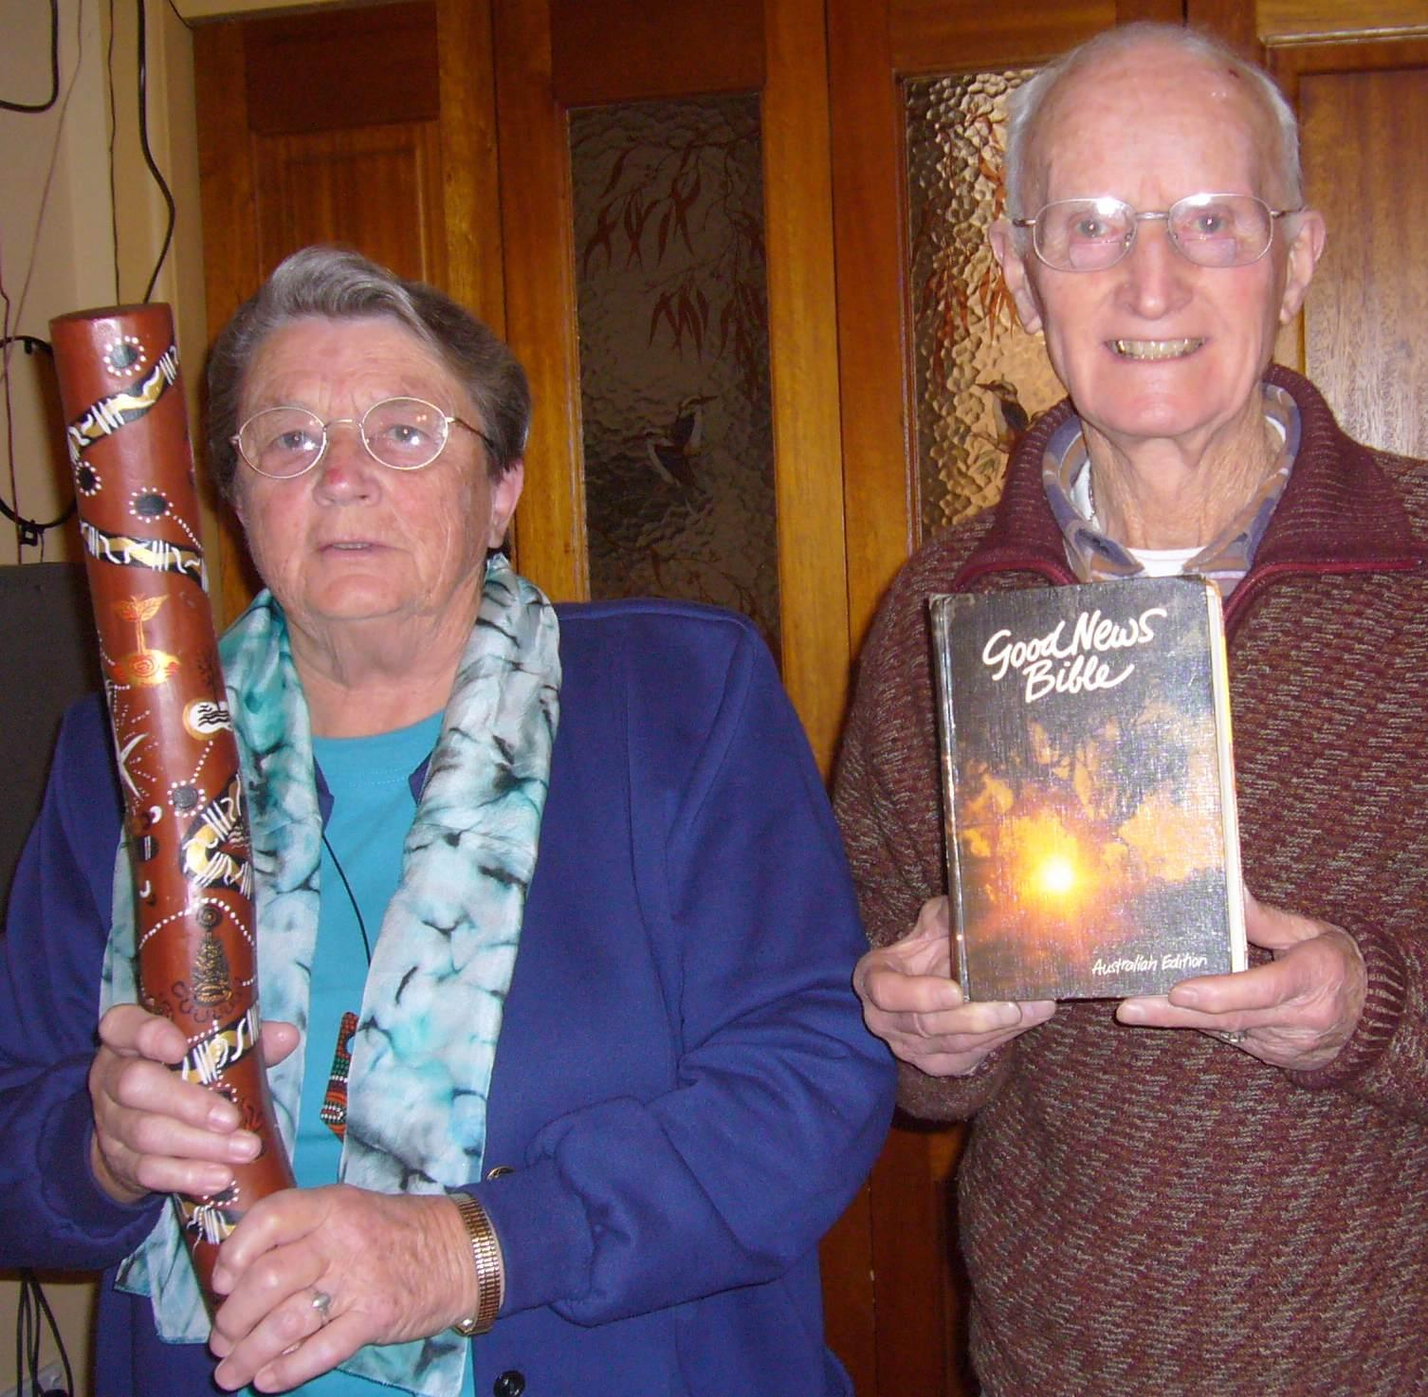  Ceremonial Lore  The Message Stick must only be used when associated with ‘The Word’ of God, carried in an upright position (see image) during the opening and closing processions. | During Mass, when the Gospel is read, the carrier holds the Message Stick next to the reader, then places the Message Stick in a prominent place.  In a Paraliturgy the Message Stick can be used in the same manner as at Mass during the chosen Biblical readings.  Protocols for using the Message Stick  Welcome/Acknowledgement of Country  It is important to begin celebrations, liturgies and gatherings with an acknowledgement of the original custodians of the land on which you are gathering. There are two ways of doing this:  Welcome to country can only be done by an Elder from the region  Acknowledgement of country (this can be done by any member of the gathered community). There are many ways to express this, the following is an example:  Today in our celebration we acknowledge the original custodians (name the local Aboriginal people) of the land on which we are standing. We thank the Elders for their care and protection of the land. We will carry on this tradition through our care for the environment.  Sacred Space  As the Message Stick is a sacred symbol of the Aboriginal people, it must be treated with reverence and respect. Developing rituals and actions that are in harmony with the meaning of the Message Stick is vital as the Message Stick itself is a powerful symbol of reconciliation (beyond the Sacramental use of the word), forgiveness, love, hope and peace and is only used when the Proclamation of The Word is made.  It is important to have simple, meaningful symbols. In this case, less is more - with emphasis in liturgy - on simplicity, rather than entertainment. The following symbols are suggestions for use when planning your celebrations. There may be others that are applicable to your local area. Think about where you hold your gatherings, often outdoors provides greater opportunity to be creative. As the Aboriginal culture is strongly connected to the land, the symbols they use thoroughly engage all our human senses – sight, sound, smell, taste, touch. The symbols that follow indicate which sense is engaged when the symbol is used.
SYMBOLS  Water The Aboriginal people have lived in harmony with the changes in the environment of drought and flood for 40,000 years, always respecting and treading carefully on the Earth. Water can be used as a Sprinkling Rite as a Welcome or as the Penitential Rite during Eucharist, a Healing or Penance Service. A coolamon or bowl and gum leaves can be used. Several drops of eucalyptus oil can be added to water as it is associated with healing and cleansing. (touch, smell). Feel the nurturing, cleansing, sustaining water. (touch) (Ezek 36,25; Jn 4,15)  Fire & Light The red flames of fire are an important symbol for Aboriginal people, as a source of heat, comfort and light giving direction, similar to our understanding of the workings of the Holy Spirit. Keeping the fire alive is vital in Aboriginal communities and traditionally a fire stick was carried from place to place. Fire can be used in outdoor celebrations. This allows a larger fire to be lit and the sense of gathering around the fire’s heat is experienced. Indoor liturgies can use a bowl of fire, enhanced by the crackle and burning of eucalyptus leaves. (smell, sight, sound, touch) (Mal 3,2; Mt 3,11; Acts 2)  Wind Our experience of wind is varied, from the parching winds of inland Australia to the cool winds that signal a break in the weather. The Aboriginal people are attuned to these changes, always patiently waiting and watching for signs of change. We use wind as a symbol of the movement of the Holy Spirit in our lives. Music and visual images can capture the symbolism of wind. (sound, sight) (Job 7,7; Mt 11,7)  Southern Cross Shaped as a cross, this formation of stars is significant in the Southern Hemisphere. As it journeys across the night sky it is a symbol of our life journey through the Paschal Mystery of birth, death and resurrection. Superb images of the night sky can be found on the internet. (sight) (Dan 12,3; Mt 2,2)  Desert The desert is in the heart of our country and is home to many Aboriginal communities. There are many references to the desert in both our Hebrew and New Testament Scriptures. It is place where the unexpected can happen. Images of the Australian desert and bowls of red sand which can be touched provide meaningful symbols. (touch, sight) (Is 40,3; Lk 9,10; Jn 6,31)  Soil, Sand Feeling the soil from which we came  and to which we will return (touch) (Gen.2,7; 3,19) | Clap Sticks and Didgeridoo  Clap sticks are used as musical accompaniment during ceremonies. They are played by holding one stick loosely in one hand and striking it with a heartbeat type rhythm with the second stick. The didgeridoo is used to call people together for song and dance. Both these instruments can be used to lead processions in liturgy (Entrance Procession, Offertory of Gifts, Recessional Procession) In particular they can accompany the Message Stick in the Gospel Procession or be played during a Sprinkling Rite (Clap Sticks are played by women and the didgeridoo by men) (sound, sight) (2 Sam 6,5; 2Chr 7,6)  Coolamons can be used during processions or to enhance the sacred space. Coolamons were traditionally (are) used by the women to cradle babies and gather food and water. In this context they can be used for baptism, holding the bread of Eucharist or water for sprinkling. (sight, touch, taste) (Mt 25,4; Acts 9,15)  Oils & Gum Leaves can be used in the sacred space for decoration and perfume. A branch of gum leaves can be used as a symbol of unity, with people taking a leaf from the branch as they either enter or leave the ceremony or liturgy. Using an oil burner or scented candles enables the perfume of the eucalypt to permeate the environment in which you are gathered. Signing the cross in eucalyptus oil on foreheads or hands can be used in ceremonies of reconciliation and healing. (smell, touch) – wattle is never used as in some Aboriginal beliefs wattle is a sign of sickness (hay fever/rhinitis). Wattle is never brought into the home. (Ex 37,29; Lk 7,46)  Appropriate situations for use of Message Stick:  Acknowledging the ancient Custodians of the land on which you are standing  Major Feasts of the Church Year and Community  Special celebrations:  The Sacraments of Baptism, Confirmation and Eucharist,  Inauguration and Induction ceremonies,  special Liturgies other than Eucharist.  Social Justice occasions  Ecumenical celebrations are especially appropriate as they embrace our unity in Christ.  School Assemblies
Liturgy planning and further information will be found on the following web-sites: http://www.acmm.org.au
http://www.passiton.org.au http://www.ncca.org.au/natsiec/resources/liturgies http://www.natsicc.org.au/liturgy.htm

