Appendix 1

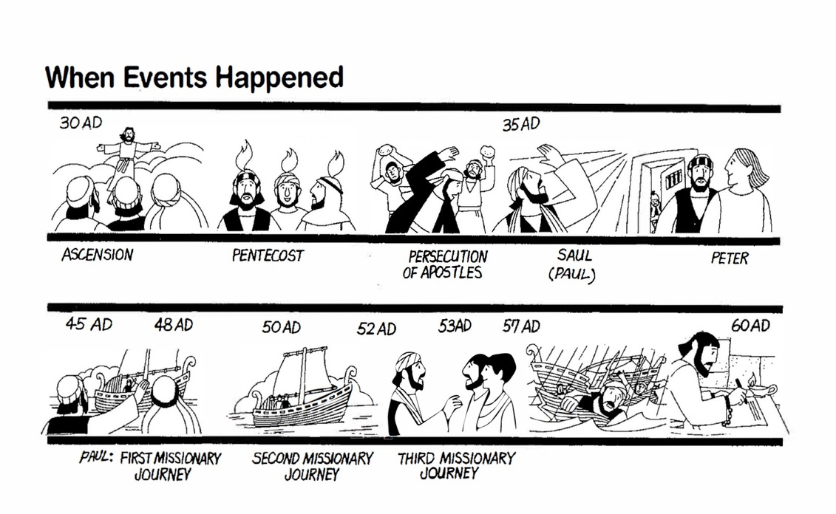
Outline of Unit Content

