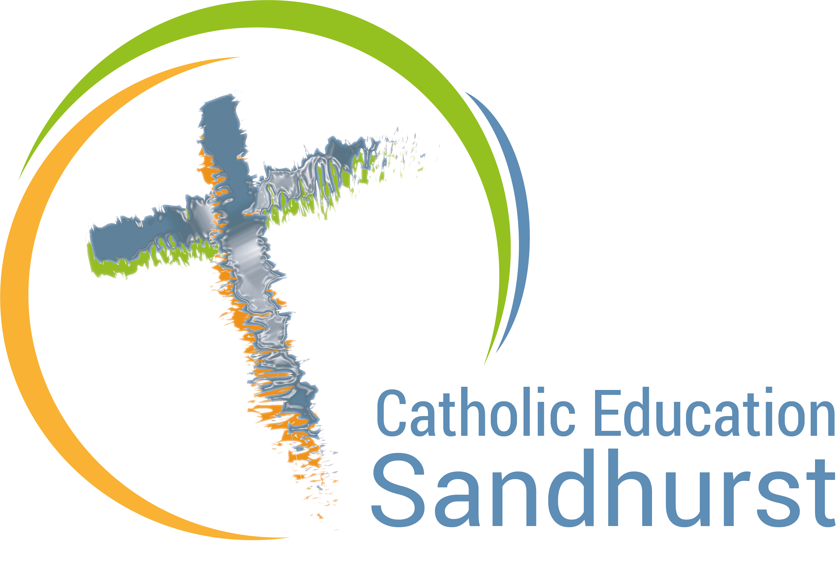
SOCIAL JUSTICE REFERENCE GROUP

Annual Action Plan 2022

SJRG Purposes
- To demonstrate that through our Catholic Identity social justice is core to Learning & Teaching, Wellbeing, Leadership and Stewardship of Resources.
- To educate and empower all members of our Sandhurst school communities to uphold and respond to the principles of Catholic Social Teaching.
- To provide a space for social justice initiatives to be generated and discerned for proposed common applications in schools throughout the diocese.
- To collect and map key social justice initiatives throughout the diocese to ensure a common voice and clear message.

Action | Purpose | Responsibility | Timeline | Completed
2022 SJ Calendar prepared  2022 SJ Calendar published | 2, 3, 4  2, 3, 4 | David  David | End 2021  Start 2022
St Josephine Bakhita Day – launch of CESL Modern Slavery Policy | 1, 2, 3 | David / Kim Saunders / Monique Chalker | Feb 8 2022
PD to Grad Teachers | 2 | David / Lee | July 29 2021
Justice Matters Camp  – School Action Planning follow up  Yr 8 Just Leadership Days  Yr 5 Just Leadership Days | 2  2  2  2 | David & Kerry  David & Kerry  Kerry & David  Kerry | May 11-13 2022  End 2022  Aug 2022  Nov 2022
Oversight of current diocesan SJ events.  Review of current events; discussion of prospective events / issues; discernment of possible gaps at diocesan level. | 3 | SJRG | Ongoing | Standing agenda item at SJRG meetings
Staff PD, eg in CST, offered | 4 | CES RE Team & Kerry | End 2022
Refugee Week resources compiled & distributed | 1, 2 | CES RE Team  Ruth | June 2022
Diocesan Winter Sleepout | 2 | David & Ruth | Aug 4 2022
Maintaining & promoting new CES SJ webpage | 1, 2, 3 | David | Ongoing
School Social Justice Planning document | 1, 2 | David & Lee  SJRG | Launch Term 1 2022  Ongoing support
CESL Laudato Si Action Plan  - Initial draft for consultation  - Launch  - Monitor, evaluate and celebrate | 1, 2, 3, 4 | SJRG | Dec 2021  Term 1 2022  Ongoing

