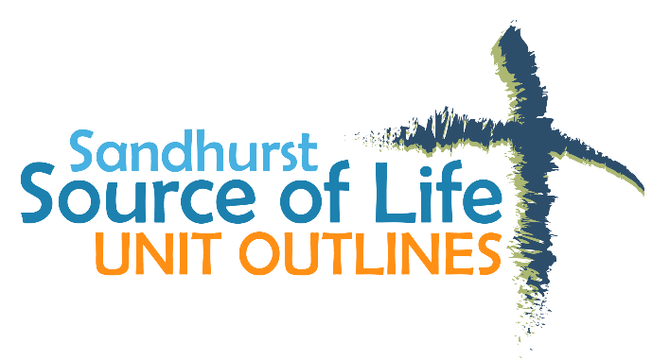
YEAR LEVEL | 5 and 6
TITLE | Life Relationships (CEPD)
STRAND | CHRISTIAN MORALITY  AND SOCIAL JUSTICE
SUGGESTED DURATION | 6 weeks

The parent/caregiver and student information evening for the Life Relationships unit supports the unit of work taught in the classroom.

Unit Focus
In this unit students focus on relationships. They will look at family dynamics, emotional and physical changes that occur during puberty and adolescence, and the reproductive system. Students will be led to an understanding that our sexuality is a God-given gift and of the importance of self-respect and respect for others.

Achievement Standards
By the end of Year 6, students should be able to:
Interpret ways that Christians can respond generously to God's love of us and all creation.

Unit Outcomes
By the end of this unit students should be able to:

- Describe characteristics of relationships and how relationships can change over time.
- Have an appreciation of the family to which they belong and understand the importance of family.
- Explain significant transitions in human development and ways in which people deal with them.
- Have an appreciation of the physical and emotional changes during puberty as part of God's gift of life to each person, and how these changes can affect family dynamics and relationships.

Key Understandings for Students
- We live in relationship.

- Because we are all created in God’s image, we are called to respect the dignity of each person.

- In life’s cycle, from conception to death there are marked stages. Our search for identity has many influences including family, peers, society and media.

- Human relationships are considered as whole person: intellectual, ethical, physical, social, emotional and spiritual.

- As adolescents we are faced with a broad range of issues and choices where we need to make informed decisions, based on family values, Church teaching, conscience, Gospel values, peer influence, media and society’s expectations.

- The adolescent stage of development includes physical and emotional changes which will affect young people differently and will have a significant influence on existing and developing relationships.

- It is important to value difference and diversity.

Theological Background for Teachers

Characteristics of Adolescence
- Expanded intellectual abilities, which enable young people to appreciate and weigh up a number of points of view before making a personal decision.

- The parent’s word may no longer be seen as ‘law’.

- An increased need for privacy to work things out in their own way, which sometimes means they ‘clam up’.

- A rapid growth process toward independent adulthood, in which sexuality will play a major role.

- An increased anxiety about body image and appearance, which often results in a lack of confidence.

- Increased respect for and interest in the friendship group, rather than the family.
Values and attitudes
- Values are abstract – not concrete.

- Values are determined by the beliefs we hold. They are ideas about what someone or a group thinks is important to life and they play a very important part in our decision making.

- Most people are influenced at any one time by 6 to 8 values.

- People hold many attitudes, which are far easier to change than values.

- People can find it difficult to identify and state their values.

- Community, family and individual values are important considerations in making decisions and taking action.

Role of the Educator:
- This sacred synod likewise declares that children and young people have a right to be motivated to appraise moral values with a right conscience, to embrace them with a personal adherence, together with a deeper knowledge and love of God. Consequently, it earnestly entreats all those who hold a position of public authority or who are in charge of education to see to it that youth is never deprived of this sacred right. (Declaration on Christian Education, n. 1).

- This validates the CEPD belief statement that Christian Education for Personal Development is the responsibility of the whole community – parents, teachers, students, parishes and the wider community. The marriage between the planned programs and the fostering of high-quality interpersonal relationships among teachers, students, parents and ancillary staff sets the tone and priority of CEPD (SSEB CEPD Policy, 1999). It also places an imperative on schools to ensure that teachers are developed in their knowledge and understanding and that they are supported with appropriate resources in supporting parents in the development of their children across all stages, especially adolescence.
Dignity of Human Life:
- At the heart of the quest for human flourishing is the fundamental moral understanding of the dignity of human persons…the subject of inalienable rights to life, liberty, social engagement and self-expression, the person bears responsibility towards self and others for the full realization of human potential. (Source of Life 2005, p. 69)

- The centrality of the Catholic belief in the dignity of all human life is fundamental to CEPD. The following excerpts from both Scripture and Church documents are the foundation for all the programs and resources that are developed to enable students to understand their personal development across the various dimensions – spiritual, physical, moral, psychological, social and cultural.

- God, the Lord of life has entrusted to us the noble mission of safeguarding life and we should carry it out in a manner worthy of ourselves. (#5, Church in the Modern World, n. 51)

- We are all equal in the eyes of God…there are no more distinctions between Jew and Greek, slave and free, male and female, but all of you are one in Christ Jesus (Galatians 3:28).

- Forms of social or cultural discrimination in basic personal rights on the grounds of sex, race, colour, social conditions, language or religion must be curbed and eradicated as incompatible with God’s design (#5, Church in the Modern World, n. 29)
Informed Conscience:
- Individuals have a responsibility to themselves and others for making informed decisions. Increasingly due to the media and pervading consumerism, students are faced with very real moral and ethical decisions that affect not only their own, but others’ lives. In developing programs and resources in CEPD and across the curriculum, teachers are guided by Church documents, including the following excerpts:

  - Conscience is the judgement of our reason about the morality of an act. It is the most sacred core and sanctuary of the human person and needs to be informed and followed. (Romans 14:22; Church in the Modern World, n. 16)

  - Conscience binds and must be followed. However, one must equally strive to develop an informed conscience based on the teachings of Christ. Conscience is not simply a still, small voice within us, but the ultimate judgement every person is required to make as to whether this or that action is right, wrong or acceptable. (Church in the Modern World, n. 16)

  - All conscience formation and decision-making should be free from coercion for ‘freedom is the exceptional sign of the image of God in the human person’ (Church in the Modern World, n. 17; Declaration on Religious Freedom, n. 1 and Religious Liberty, n. 2)

- Catholic theology stresses the important role that conscience exercises in determining right from wrong. It enables us to recognize what is loving and what is not, what helps growth and what inhibits it. It is the final norm for judging the morality of our actions. It can be defined as the attempt to discern the moral values at stake within particular situations. No one else’s judgement can take its place.
- In order to be fully moral, that is truly human, we need to continue to form our conscience with the assistance of church teachings. It is an approach that respects human choosing in the midst of the believing faith community.
Student Diversity and Cultural Context
- Awareness of and sensitivity to the diversity among students is crucial to ensuring that programs are relevant. This diversity relates to gender, religion, race, culture, sexual orientation, socio-economic background, age and disability. It must be acknowledged that students are not a homogeneous group and subsequently care must be taken to avoid discrimination.

- Schools exist in a diverse, social context in which young people are exposed to a plethora of images and messages via the media and peers. Students need to engage in meaningful activities based on the values of the Catholic school community such as commitment and mutual respect in all relationships and decision making.

Pastoral Care:
- While Catholic schools have always given emphasis to the Pastoral Care of students, there is today a certain urgency to its challenges and responsibilities. Rapid and complex social change is resulting in substantial uncertainty, insecurity and stress in families, in the community at large and amongst the students in our schools.

- Pastoral care in the Church draws its inspiration and strength from the life of Jesus Christ. In Jesus we see God’s paramount expression of love, compassion, reconciliation, and justice. (Catholic Education Commission of Victoria Policy 1.14, Pastoral Care of students in Catholic Schools)

- The following excerpt from the Sandhurst School Improvement Framework encapsulates the understanding and focus for Pastoral Care across Catholic schools of the Diocese.
A Pastoral care framework incorporates:
- The provision of a safe and supportive environment for all members of the school community;

- An awareness of and a response to student diversity;

- Educating students to become resilient, self-determining, independent and active members within the community

- Community representation in the development and review of policies and processes (SSIF, 2005, p. 50)
The Christian Vision
- Has as its focus the life of Jesus Christ.

- Is concerned with the dignity and integral growth of the person;

- Is a responsibility entrusted to all members of the faith community;

- Is a force for healing, reconciliation and liberation;

- Is an expression of and commitment to justice
The Catholic Church teaches that:
- Sexuality is a gift for the human person to enhance self and relationships.

- Sexual intimacy finds its fullness in the commitment of a marriage relationship.

- Sexual intimacy integrates the physical, emotional, social, intellectual, and spiritual aspects of the human person.

- Sexual acts have two functions: They are both unitive and procreative.

- Unitive means that the couple are brought together in a special way through intercourse. Procreative means that sexual intercourse has the potential to start a new life. Artificial contraception divides these two functions and therefore makes sexual intercourse incomplete.

- Homosexual acts cannot be procreative.

- Sexual acts that do not respect the value of each person, diminish the dignity and wellbeing of individuals and affect the wider community.
The Church teaches this because:
- We are created with dignity that gives us rights, responsibilities and uniqueness.

- Every human act, sexual and otherwise, should enhance the image, dignity and respect of individuals.

- Of the need to maintain standards, to protect and promote these values.

Our Faith Community understands:
- While we are called to life giving relationships, commitments and responsibilities, our failures do not condemn us but through forgiveness and amendment we continue to seek fullness of life.

- While Church laws and teachings serve the community and present values and standards for all, each individual must conscientiously live ones faith in real life situations.

- The spirit of God is within each one of us.

Scripture
Galatians 3:28
We are all equal in the eyes of God… there are no more distinctions between Jew and Greek, slave and free, male and female, but all of you are one in Christ.
John 15:12
This is my commandment, that you love one another as I have loved you.

Major Assessment Task
Your task is to explain the characteristics of healthy and positive relationships within a family or among our friendships.

You also need to present your learning about the physical and emotional changes that we experience during puberty and how these can affect our relationships.
Your work needs to include:
∙ A “Word Web” about the characteristics of relationships.
∙ A continuum showing the significant transitions of physical human development.
∙ A Facts and Feelings diagram to record the emotional changes we can experience as we change and develop physically.

Suggested Teaching & Learning Experiences
The Group Agreement
As with any sensitive issue, it is important to establish a climate for programs in relationships and sexuality education. A useful strategy for this is to establish a ‘group agreement’ to decide the limits of group behaviour. (This can be an extension of class rules which may have been established earlier in the year).
∙ Suggest that one way the group can get the most out of this program is to have a group agreement, like rules that the group agrees on, to make it safe to talk openly. Using an agreement ensures that everyone is treated with respect, finds out what they want to know, and feels safe enough to share what they already know.
∙ Brainstorm suggestions the group has for achieving this result. Concepts such as ‘no put downs’, confidentiality and respecting privacy should be included.
∙ It is also timely at this stage to introduce or revisit the following concept:
‘Everyone has the right to feel safe all of the time’. What does ‘safe’ mean’?
How does our body let us know when we don’t feel safe? How can we make other people feel safe?
∙ Suggest that we already know that there are many words to describe our sexuality and particular body parts. In our time together we are going to practise using ‘formal’ or ‘socially acceptable’ language that everyone can understand.
As you work through the program, the ‘group agreement’ can be referred back to as necessary. This can often provide support when dealing with inappropriate comments, questions or behaviours.
Set up a Question Box. A question box allows students to ask questions anonymously and can encourage a broader range of questions than would be asked verbally. The question box can be labelled and left in the room. Students can be encouraged to write questions, concerns or issues they would like to discuss, at any time. Questions can be sighted by the teacher well in advance of the lesson, giving the opportunity to group similar questions together and prepare answers to questions.
Relationships
What are some of the important ingredients for keeping relationships going?
What does ‘relationship’ mean?
Who do we have relationships with?
How do we feel when we are in a ‘good relationship’?
How can we make others feel good about themselves?
What do we mean by communication?
What do we mean when we say someone is a good listener?
In groups of 3, discuss what good communication & poor communication looks likes. (consider: listening, body language, eye contact, tone of voice)
What are some of the important ingredients for keeping relationships going?
Teacher’s Note
Explain that healthy relationships include physical contact: a hug when you are hurt, a pat on the back, a kiss and a hug of welcome or goodbye.
Part of growing up can also include developing a sexual attraction in some relationships. Over a period of time relationships can develop to the point where adults will want to make a commitment to each other. It is at this point that people usually choose to marry and enter into a sexual relationship. Physical contact is an important part of a healthy relationship.
We all need a sense of love and belonging. We also need to be told that we are loved.
Relationships happen in context with the wider world
Discuss:
What does this mean?
How do relationships in my community affect me?
What are some of the ways Jesus and our Church have tried to promote healthy, life giving relationships?
The best of ourselves
Design a series of posters that illustrate how we become confident, worthwhile, competent, loveable, positive and independent with a high self- esteem.
(Consider what makes you feel good? Can you influence your feelings? Are some feelings a habit?)
Teachers’ Note:
Explain that we need our relationships to be working well in a wider world that is keeping us safe, secure and well connected to be the best of ourselves.
Family
Discuss
What do we mean by ‘family’?
How does your family influence your values and attitudes?
What influences your ‘identity’?
What do we mean by ‘identity’?
Read the picture story book I’ll take you to Mrs Cole.
Explore the concept of different family types, and the concept of perceptions and difference. Think about your family:
How are we alike?
How are we different?
Write in the spaces provided, a short description of features of different people in your family?

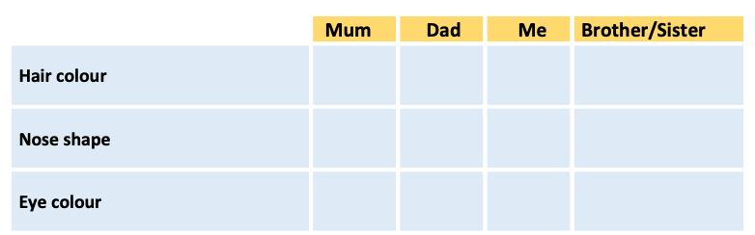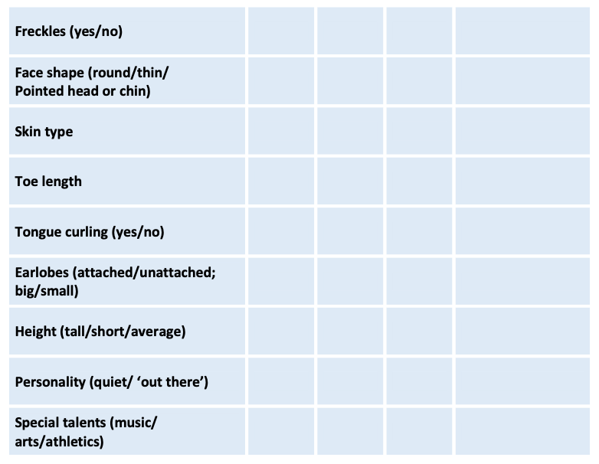
Puberty and Adolescence
Discuss:
What do we mean by adolescence being a time of ‘whole person’ growth and development? What do we mean by relationships being: physical, social, emotional, ethical, spiritual, and intellectual? What does puberty mean?
What does adolescence mean?
What are some of the pressures that adolescents face?
In groups, students cut out magazine pictures that represent different stages of life, such as: baby, toddler, pre-schooler, child, adolescent, young adult, middle-aged and elderly. Try to include male and female examples. Make a collage in order of age and use the following questions for each stage of the life cycle. What physical changes are being experienced?
What are the person’s needs at this stage?
What roles and responsibilities might they have?
How might they be feeling at this stage of their life?
What family celebrations might they experience at this stage of their life?
What things can or can’t they do?
What types of relationships might this person have?
For all of the above questions, did the response differ if you were discussing a male or a female? Why? Why not?
Teachers’ Note:
While magazines are being used it could be timely to discuss:
How do messages covered in magazines and popular television shows influence the decisions we make? Are the images ‘real’?
How important is it to look ‘glossy’ and have the latest gear?
Explain that most magazines use digital enhancement to make models look taller and thinner. Skin blemishes also vanish into the computer.
Students devise interview questions to be used with a parent or an adult relative about puberty. Ask the class to think about questions that they would like to ask.
List these on the board and together decide on about six to eight questions to use. For example: When you were my age, what did you do on the weekends? How did you have fun? What made you happy or sad?
Which changes concerning puberty did you notice first? How did they affect you? (Socially, physically, emotionally)
How comfortable did you feel about the physical changes? Did anyone offer you support? Who did you go to for help?
Using the responses from the interviews students discuss:
In what ways is life different/ the same for young people today?
Where did young people get most of their information about sexuality? Has this changed?
The Feelings Grid can be processed in many ways including the following suggestions: One student acts out an emotion on the grid and gets the others to guess what it is. Cut up two copies of the ‘Feelings Grid’ (you will need two of each emotion). Give each student a card with an emotion on it. Have students walk around the room expressing their emotion, while trying to find their partner, who is the person expressing the same emotion. After a few minutes ask students to stop and try to guess the emotions expressed by other students. Discuss how they felt acting out their emotion. Read out the following scenarios and have the students use the grid or any other feelings they can think of, to describe how the person in the scenario feels.

- You have just got home from school to find out that you have lost your key and can’t get in. Your parents won’t be home for another two hours.

- You have just been told that you didn’t make the cricket team. You have been training for six weeks.

- You have just copied your friend’s homework.

- Your mother has just had a baby.

- Your face has broken out in pimples.

- Your friend has just ‘uninvited’ you to her birthday party on Saturday night.

- There is a boy/girl in your class who lives in the same street as you. You have played together since you were two, but now your friends make fun of you saying he/she is your boyfriend/girlfriend.

- Your mum brings you to school each day and insists on kissing you goodbye in front of everyone.
Discuss:
What could the ‘self-talk’ be for each of the scenarios.
How could your ‘feelings’ and ‘self-talk’ affect your behaviour?

Feelings Grid

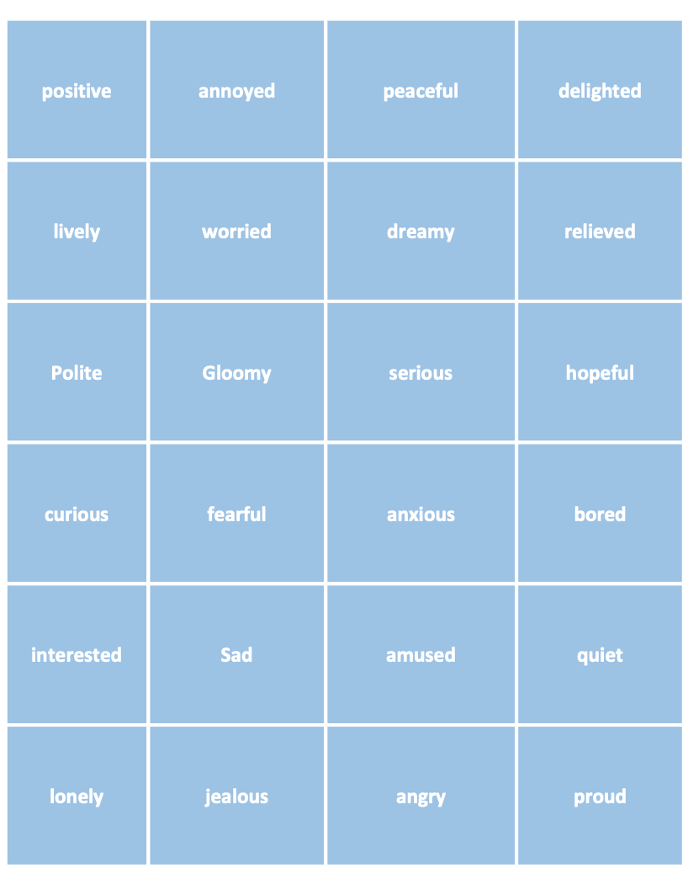

Teacher’s Note:
Developing a language around the way we feel is an important part of our emotional development. As adolescence is a stage of the life cycle where emotions are fairly rampant, it is important to emphasize the connections between feelings, thoughts and, behaviours in relation to wellbeing. Sometimes we can be confused about just how we feel. Feelings are neither good nor bad they just are. Some feelings are easy or comfortable to deal with, for example happiness, pride and excitement; others such as anger, loneliness, and jealousy are uncomfortable, but are a part of life. Feelings should be treated as valid and acceptable even if the behaviour is not. Emotional feelings can also work in conjunction with body signals or physical sensations, for example; a fast heartbeat, butterflies in the stomach or tears of joy. It is important to recognise both emotional and physical feelings and be able to work out why we feel the way we do. We can use our thoughts or ‘self-talk’ or the ‘voice inside our head’ to change the way we feel. Positive ‘self-talk’ can help us motivate ourselves so that our uncomfortable feelings go away.
Talk about the word ‘behaviours’, things people do.
Ask the students, individually and then in a large group, to make a list of behaviours, For example: sleep, eat, play sport, go to the toilet, play chess, go to school, have sexual intercourse, ride bicycles, drive cars, have a shower, cross the road, drink alcohol, inject drugs, smoke cigarettes. (Scribe these behaviours on the board or on butcher’s paper.)
Look at the huge list and in the large group, rate the behaviours in terms of ‘risk’.
10 points represents the highest risk and 1 point the lowest risk.
While there are many different types of behaviours, most of which involve some risk, there are some behaviours which involve a great deal of risk to health and safety.
Teacher’s Note:
Explain that adolescence is a time when young people generally increase their risk-taking behaviours. This is very normal. Healthy risk taking is how we learn, e.g. riding a one wheel bike could be seen by some as risky but could result in learning a great skill; going to a party when we don’t know many people could be risky but could widen our circle of friends.
Teachers have a relationship with their class and are in the best position to assess the depth of information required in this area. It is important to dispel myths as well as give accurate information.
Reproduction
Our bodies are made up of many different systems.
‘Brainstorm’ the systems of the body, then illustrate them.
Male Reproductive system
Refocus on the male reproductive system and wet dreams.
Discuss:
What do we know about the male reproductive system?
Why do males have ‘wet dreams’?
Why do people sometimes feel uncomfortable talking about ‘wet dreams’?
Why do girls need to know about wet dreams?
Female Reproductive system
Refocus on the female reproductive system, the female genitals and menstruation.

Discuss:
What do we know about the female reproductive system and genitals?
Why do women have periods or menstruate?
Why do some women sometimes feel uncomfortable when talking about periods or menstruation? Why do boys need to know about periods or menstruation?

Males
Match the following words with their definitions
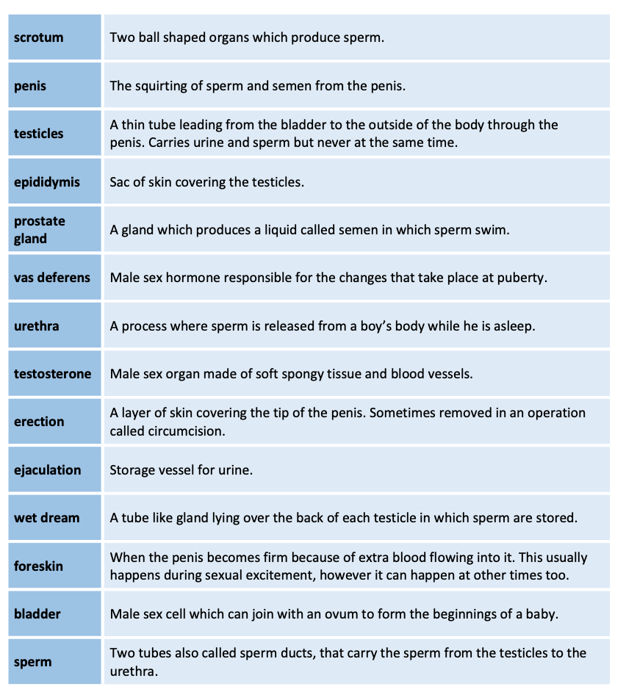

Females
Match the following words with their definitions

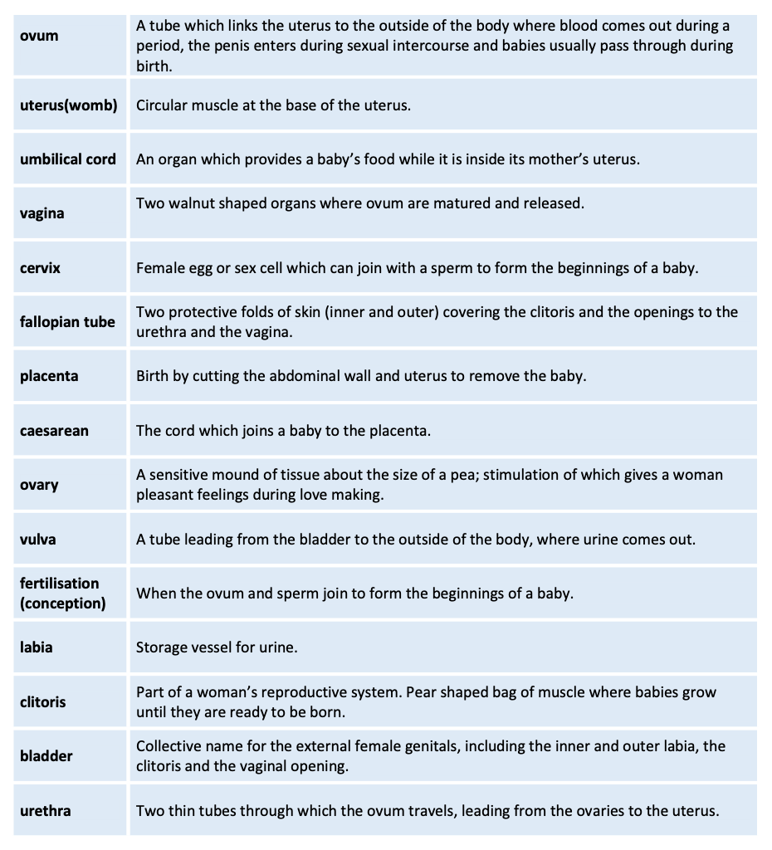
Menstruation
Refocus on the female reproductive system and menstruation.
Show examples of pads and tampons most commonly used for menstruation.

Place three or four tablespoons of water in a clear plastic cup with some red food colouring. Either demonstrate placing one teaspoon of coloured water on a pad, to represent about the average amount of blood which is lost per half day, or give small groups of students pads, and ask them to place different amounts of coloured water on the pads. Experiment with absorption.
Note that about three tablespoons to half a cup of blood will be lost in total, during a menstrual cycle, with half of that amount being discharged on the first day.
Place a tampon in a cup of water to demonstrate absorption.
Complete the true / false ‘discussion starter’ about menstruation.
Menstruation
Which of the following statements are true or false?
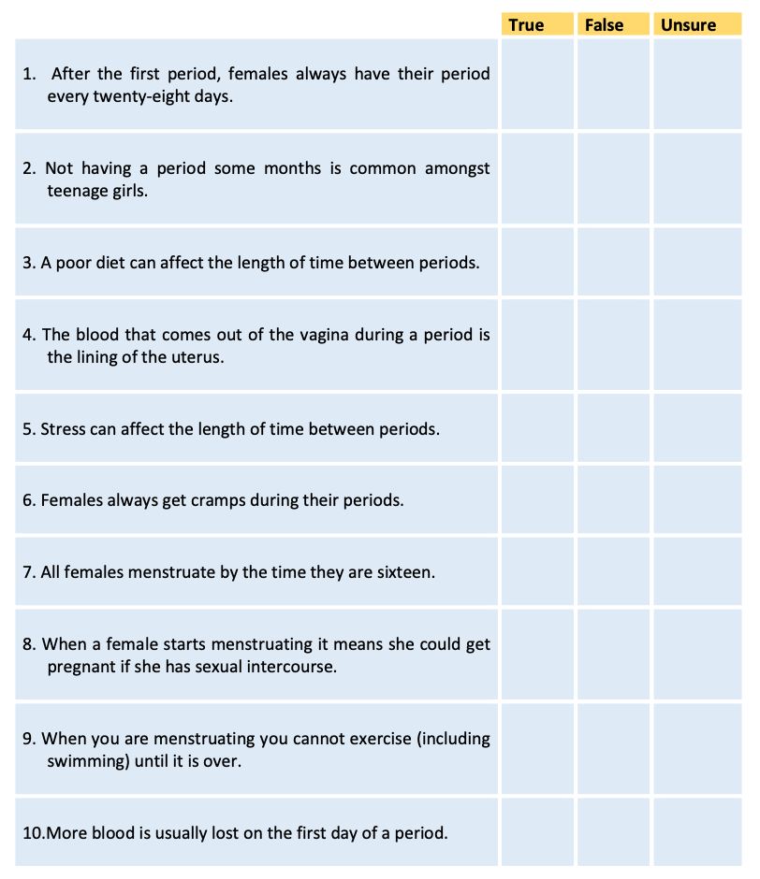

Menstruation
Which of the following statements are true or false?
ANSWERS

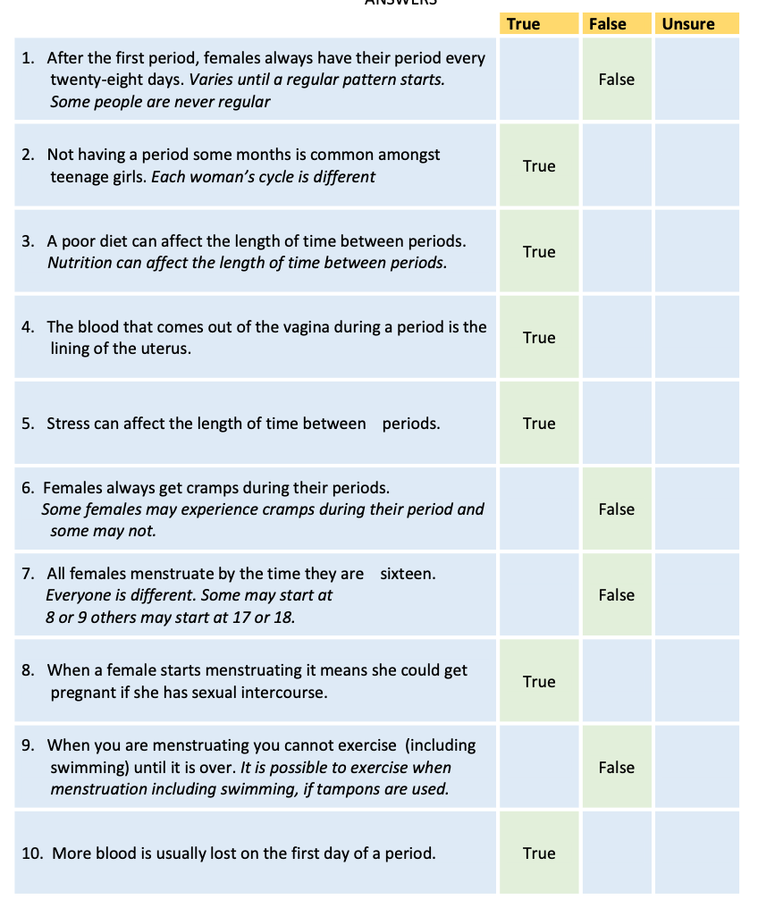

Teacher’s Note:
Separate Sessions for girls and boys
While it is important for young men to learn about the female reproductive system, and for young women to know about the male reproductive system, it may also be appropriate to separate the boys and the girls for a session to allow time for discussion and questions.
Some will feel intimidated in a mixed group.
In reviewing the hygiene facilities available in the girls toilets, consider having more than one toilet with a sanitary disposal unit. This negates the need for girls to line up when other toilets are vacant.
Girls
Additional discussion starters for a ‘girls only’ group
What do you think menstruation feels like?
Discuss amount of blood loss. Demonstrate (as above).
What hygiene measures are associated with menstruation?
To whom would you talk to find out more about menstruation?
How would you begin discussing menstruation with that person?
What does PMT mean?
In what ways could you be more caring and tolerant when someone is menstruating? Discuss sanitary products
Discuss the disposal of sanitary products, review school facilities.
Breast and body shapes (Refer to page 59. Sexuality in Context)
What about the media, and how it tells us how to act, what to buy and what to look like?
Boys
Additional discussion starters for a ‘boys only’ group
What do we know about hygiene for boys as they reach puberty?
Include a discussion of circumcised and uncircumcised penises, (Refer to Pg. 59. Sexuality in Context) testicular checks, growth of facial hair, body building etc.
What are some of the rituals and customs that we know of that celebrate the maturing of a boy into a man? (for example The Jewish Bar Mitzvah, Indigenous Rites of Passage.
What are some of the issues that are associated with puberty from a boy’s point of view? What would it be like to be the first or the last boy in your class to go through puberty? What about the media, and how it tells us how to act, what to look like, and what to buy? Is it true that ‘big boys’ don’t cry?

Appendices
Appendix 1: Teacher notes

